LCA

Communication to the agents
  - MT 21298 Mould Engraving

Contents
1. Introduction 2
1.1. Quality and environmental management 2
1.2. Purpose of the study 2
1.3. Eco-designed product 3
1.4. Raw materials used 3
2. Considerations of the eco designed products 3
2.1. Usage considerations 3
2.2. Recyclability considerations 3
2.3. Environmental improvements 4
3. Impacts 4
3.1. Methodology and data 4
3.2. Environmental impacts 4
3.3. Comparative 5
4. Conclusions 6

Introduction

Quality and environmental management
Our policy of continuous improvement also requires a demanding and responsible work, which has led to the implementation of the UNE-EN-ISO 14006: Environmental management systems Guidelines for incorporating eco-design in our Quality Management System and Environment.
Eco-design is understood as a process integrated within the design and development that aims to reduce environmental impacts and continually to improve the environmental performance of the products, throughout their life cycle from raw material extraction to end of life.
In order to be of benefit to our organization and to ensure that we achieve our environmental objectives, we carry out eco-design as an integral part of the business operations of our organization.
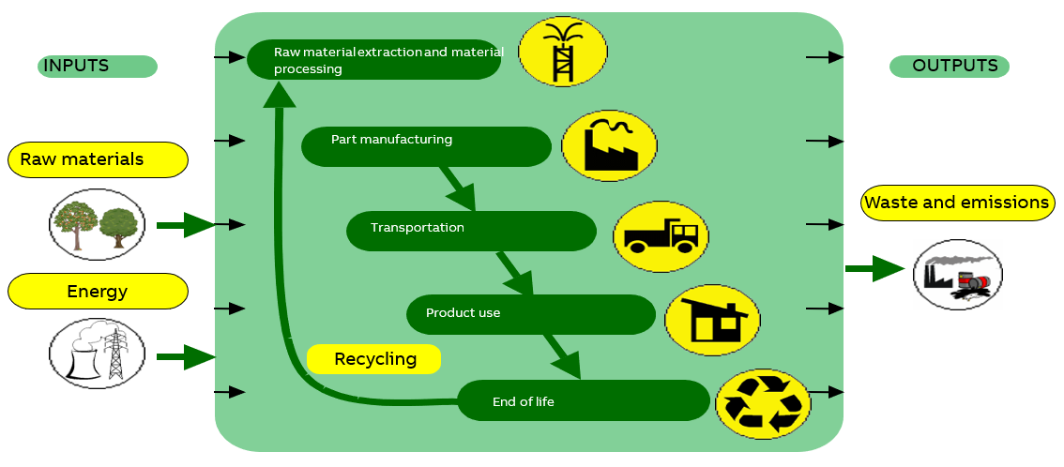

So in 2007 Asea Brown Boveri, S.A. NIESSEN factory, certify the Environmental Management Design and Development process according to UNE 150301. To subsequently adapt the system to the international standard UNE EN ISO 14006.
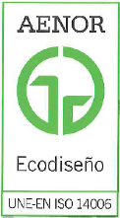

ED-0008/2007

Purpose of the study
In this study the process of engraving the Niessen logo by pad printing on each functionality has been compared against marking it directly on the plastic mould of the outside frame seeking for an improvement.

Eco-designed product
Representative products | Different functionalities from Arco.
Description of the products | Different functionalities that share the same outer frame
Functional unit | Engraving of Niessen Logo for one year production
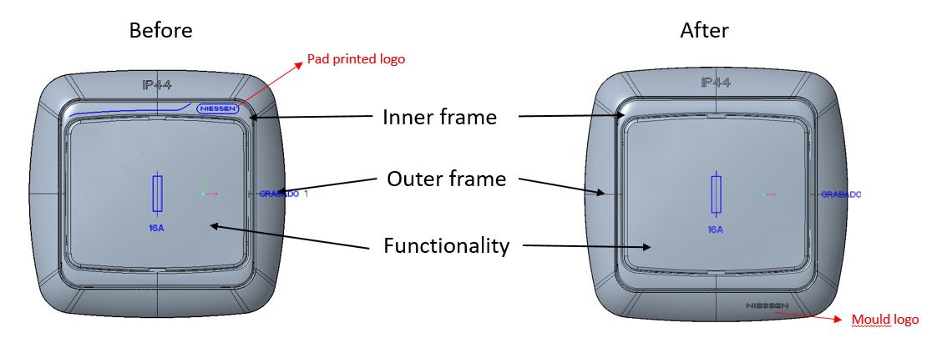

Raw materials used
The Raw materials used for this study are the ink, hardener and thinner used to pad print the logo.

Considerations of the eco designed products

Usage considerations
- Make strong electrical connections; this will prevent heat loss in connections, and unnecessary energy consumption.

Recyclability considerations
-The cardboard packaging is recycled
-The plastics are recyclable, and they include a marking inside (indicating the material they are made of) so they can be disassembled.

Environmental improvements
-Elimination of use of halogenated flame retardants, by using halogen-free materials.
-Minimum cardboard for recyclable packaging
-Minimum number of components, thereby savings in energy and raw materials in manufacturing processes.
-Use of water-based paints, avoiding the use of solvents harmful to the environment.
-The change of components in the electronic circuit achieves a reduction in energy consumption of 3% in the use stage.
-The change of components in the electronic circuit achieves a reduction in energy consumption of 100% in the standby stage.
- One time impact…

Impacts

Methodology and data
For this analysis the software Simapro Flow has been used, with the database Ecoinvent 3.6 Cut-off.
The calculations have been made with the methodologies IPCC GWP 100a and CML-IA baseline. With this methodology is studied the abiotic depletion, the air pollution, the ozone layer depletion, the water pollution, the photochemical oxidation, eutrophication, global warming and the acidification.
It is taken into account the entire lifecycle, which include the manufacturing, transport, use and the end-of-life stages. As we are comparing a modification in an element, in many of the stages (transport, use and end of life) there is not any variation.
The data has been obtained from the company’s data base SAP and different technical datasheet.

Environmental impacts
Using the “CML-IA baseline” method, these compulsory indicators are calculated, which explanations are in the Appendix.

BEFORE
Impact indicators | Unit | Total | Manufacturing | Transport | Use | End of Life
Global warming (GW) | kg CO₂ eq. | 5,868E-01 | 4,97E-01 | 7,65E-03 | 0,00E+00 | 8,24E-02
Ozone depletion (OD) | kg CFC-11 eq. | 5,646E-06 | 5,64E-06 | 2,69E-08 | 0,00E+00 | -2,36E-08
Acidification of soil and water (A) | kg SO₂ eq. | 4,532E-08 | 4,42E-08 | 1,42E-09 | 0,00E+00 | -2,51E-10
Eutrophication (E) | kg (PO₄)³ eq. | 1,782E-04 | 1,59E-04 | 9,97E-07 | 0,00E+00 | 1,79E-05
Photochemical ozone creation (POCP) | kg C₂H₄ eq. | 1,955E-03 | 1,95E-03 | 2,44E-05 | 0,00E+00 | -1,54E-05
Depletion of abiotic resources – elements (ADPe) | kg Sb eq. | 9,342E-04 | 7,94E-04 | 5,43E-06 | 0,00E+00 | 1,35E-04

AFTER
Impact indicators | Unit | Total | Manufacturing | Transport | Use | End of Life
Global warming (GW) | kg CO₂ eq. | 1,139E-01 | 2,38E-02 | 7,65E-03 | 0,00E+00 | 8,24E-02
Ozone depletion (OD) | kg CFC-11 eq. | 3,159E-07 | 3,13E-07 | 2,69E-08 | 0,00E+00 | -2,36E-08
Acidification of soil and water (A) | kg SO₂ eq. | 3,793E-09 | 2,63E-09 | 1,42E-09 | 0,00E+00 | -2,51E-10
Eutrophication (E) | kg (PO₄)³ eq. | 2,438E-05 | 5,50E-06 | 9,97E-07 | 0,00E+00 | 1,79E-05
Photochemical ozone creation (POCP) | kg C₂H₄ eq. | 1,415E-04 | 1,33E-04 | 2,44E-05 | 0,00E+00 | -1,54E-05
Depletion of abiotic resources – elements (ADPe) | kg Sb eq. | 2,274E-04 | 8,73E-05 | 5,43E-06 | 0,00E+00 | 1,35E-04
Depletion of abiotic  resources – fossil fuels (ADPff) | MJ | 3,387E-01 | 2,67E-01 | 1,14E-01 | 0,00E+00 | -4,27E-02
Water pollution (WP) | m³ | 2,246E-01 | 1,38E-01 | 4,60E-03 | 0,00E+00 | 8,20E-02
Air pollution (AP) | m³ | 6,647E-01 | 5,27E-01 | 1,39E-01 | 0,00E+00 | -1,36E-03

Comparative

The graphic shows the changes made and the impact differences. There has been an improvement due to the reduction of chemicals used for the ink.

Conclusions

As seen in the graph, the ink is the most impactful aspect. Pad printing one or 100 pieces requires the same amount of ink, and each lot produces new impacts. Mould engraving is a one-time impact, where the electricity is the most important aspect.

Note: The presentation of these texts’ wrath according to the medium used (web, catalogs, instructions) so it does not always have this format.

Cecilia de Acha
Development Responsible

03/03/2020

Appendix
Impact indicators | Description | Unit
Global warming (GW) | Indicator of potential global warming caused by emissions to air contributing to the greenhouse effect. Includes fossil and biogenic | kg CO₂ eq.
Ozone depletion (OD) | Indicator of emissions to air that contribute to the destruction of the ozone layer | kg CFC-11 eq.
Acidification of soil and water (A) | Indicator of the potential acidification of soils and water caused by the release of certain gases to the atmosphere | kg SO₂ eq.
Eutrophication (E) | Indicator of the contribution to eutrophication of water by the enrichment of the aquatic ecosystem with nutritional elements, e.g. industrial or domestic effluents, agriculture, etc. | kg (PO₄)³ eq.
Photochemical ozone creation (POCP) | Indicator of emissions of gases that affect the creation of photochemical ozone in the lower atmosphere (smog) because of the rays of the sun. | kg C₂H₄ eq.
Depletion of abiotic resources – elements (ADPe) | Indicator of the depletion of natural non-fossil resources | kg Sb eq.
Depletion of abiotic resources – fossil fuels (ADPf) | Indicator of the depletion of natural fossil resources | MJ (lower heating Value)
Water pollution (WP) | Indicator of the quantity of water necessary to dilute the toxic elements poured into water in all the stages of the product life cycle. | m³
Air pollution (AP) | Indicator of the quantity of air necessary to dilute the toxic elements emitted into the air in all the stages of the product life cycle. | m³

