—

Medium voltage products

|  |
| --- |
| **ABB Electrification Products Division**  **UniSec Pricelist** |

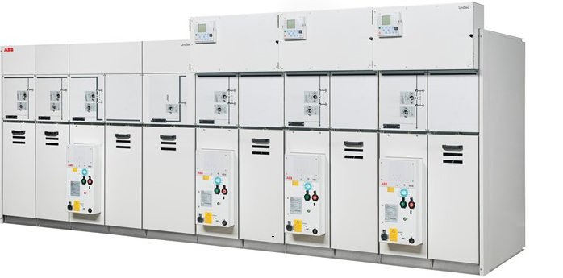

**Table of Contents**

1 Digital Monitoring Solution 3

2 General Information 4

3 General Specification: Price List 2021 (Unisec 630A 16kA HD4/VD4) 5

3.1 General Data / Type of apparatus 5

3.2 Electrical Data 5

3.3 Additional Data 6

3.4 Auxiliary supply and wiring data 6

3.5 Switchgear Accessories 7

3.6 Switchgear Composition: Price List 2021 (Unisec 630A 16kA VD4/HD4) 7

4 Typical Unit Description 8

4.1 Panel: SBC CT (REF601) 8

5 General remarks and clarifications 10

6 Routine Tests and Factory Acceptance Test (FAT) 11

7 Service Proposal 13

7.1 Service 13

7.2 Installation Services 13

7.3 Corrective Services 13

7.4 Preventive Services 14

7.5 Value Added Services 14

7.6 Training Center 15

# Digital Monitoring Solution

UniSec Digital is the ABB solution that provides full connection and communication within the network while meeting the latest demanding distribution requirements.

SWICOM is a monitoring and diagnostic unit which provides mechanical and electrical health status of a fleet lineup. It acquires data communicating with IEC 61850 based protection relays and via sensor bus of additional e.g temperature sensors and converts the data to diagnostic information.

Key benefits:

▪ SWICOM monitors breaker drive, temperatures in critical points on primary circuit and partial discharge using an indicator

▪ Any existing panel can be completely modernized regardless of the age, design and brand, becoming ABB digital compliant.

▪ Quick and easy implementation into a truly digital switchgear also when the panel designs are not set for the application.

▪ SWICOM is a core enabler to increase flexibility, efficiency, safety, productivity and reliability

Key features:

▪ One unit covers information from whole switchgear lineup.

▪ SWICOM can be installed on ABB and non-ABB medium voltage switchgear.

▪ Asset management ensured with real time data of the circuit breakers and switchgear.

▪ Asset condition visible by using touch HMI and a mobile app for smart devices.

▪ SCADA connection through IEC61850 and through MODBUS over TCP/IP possible.

▪ Connect SWICOM to ABB Ability™ Edge Industrial Gateway cloud-based dashboard to remotely view asset health status.

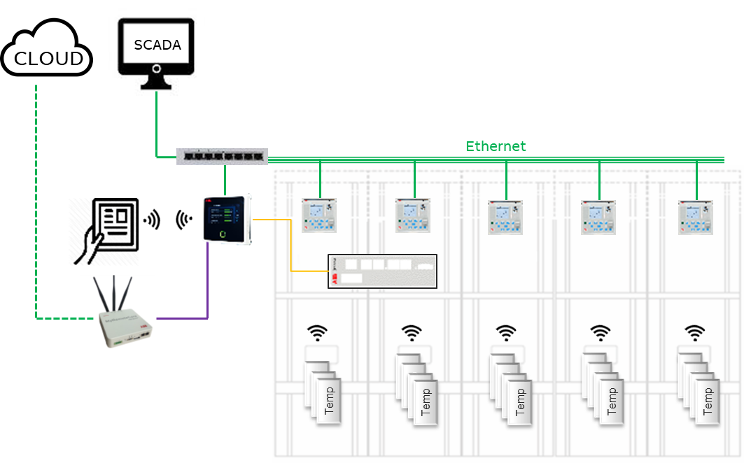

1. Breaker monitoring through Relion relays

2. Partial Discharge detection through PDCOM

3. Wireless Temperature monitoring

4. Infrared Temperature monitoring

5. Data visualization

Do you need any further information, feel always welcome to contact us

Phone: +62 21 8060 0634

Email: [contact.center@id.abb.com](mailto:contact.center@id.abb.com)

# General Information

**Unisec Price List**

* Price in this catalogue is unit price
* Price is excluded VAT
* Delivery term: Ex-work ABB Tangerang Factory, without wooden packing
* Warranty Period: 18 months from date of delivery or 12 months from date of commissioning, whichever is come first.
* Exclude FAT and commissioning / supervision
* ABB Standard Term and Conditions are applicable
* Prices are subject to change at any time without prior notice
* The price list is valid until February 2022 and unless amended or withdrawn
* The Price is included the Main Busbar for the dedicated Panel only (The busbar length considers same as panel width)
* Joint Plate between panel and Lifting Lug for each Panel are included
* The painting is use for standard painting RAL 7035
* All Accessories are excluded

# General Specification: Price List 2021 (Unisec 630A 16kA HD4/VD4)

|  |  |  |  |  |
| --- | --- | --- | --- | --- |
| General Data / Type of apparatus | | | |  |
| **Air insulated MV switchgear for secondary distribution type UniSec** | |  | | |
| * Type: | Complete switchgear | | | |
| * Application: | Standard IEC 62271-200 | | | |
| * Additional technical requests: |  | | | |
| * Degree of protection: | IP3X | | | |
| * Internal Arc Classification (IAC): | Front Accessibility (AF) | | | |
| ATTENTION: IAC A-F version - No access to rear and sides of the Swg while is in service. Installation distances to be respected. | | | | |
| * Type of apparatus: | Switch disconnector type SF6, Circuit breaker type SF6 (HD4/R-Sec) **or** Vacuum (VD4/R-Sec) | | | |
| * Packing: | Domestic | | | |
| * Ambient temperature (Mim/Max): | -5°C /40°C | | | |
| * Storage temperature: | -5°C | | | |
| * Altitude: | ≤1000 m | | | |
|  | | | | |
| Electrical Data | | | |  |
| * Rated voltage: | | | 24kV | |
| * Service voltage: | | | 20kV | |
| * Power frequency withstand voltage: | | | 50kV | |
| * BIL: | | | 125kV | |
| * Rated frequency: | | | 50Hz | |
| * Rated busbar current: | | | 630A | |
| * Rated short circuit current: | | | 16kA | |
| * Rated short circuit current duration: | | | 3s | |
| * Peak current: | | | 40kA | |
| * Arc test current 1s (According to IEC 62271-200): | | | 16 kA | |

|  |  |  |
| --- | --- | --- |
| Additional Data | |  |
| * Internal lighting | No | |
| * Anti Condensation heater of self-regulating type | Yes, in cable compartment | |
| * Voltage presence indicating system | Fixed lamps, type VPIS | |
| * Type of key locks interlocking (if selected in functional units) | Giussani | |
| * Address labels on functional units | Yes | |
| * Mimic diagrams | Yes | |
| * Routine test reports | Yes | |
| * Our ABB standard drawing template | Yes | |
| * Switchgear colour | RAL 7035 | |
| * For SF6 CB HD4/R-sec the pressure indicator is not included in price list * For CT with low primary current (below 75A) please consult with ABB Factory * VT which is not supplied by ABB must be installed by ABB or authorized person under license of ABB | | |
| Auxiliary supply and wiring data | |  |
| * Local control voltage: | 230VAC | |
| * Spring charging motor voltage for CB: | 230VAC | |
| * Control circuits cross section | 1.5 mm2 | |
| * Voltage circuits cross section | 2.5 mm2 | |
| * Current circuits cross section | 2.5 mm2 | |
| * Earthing circuits cross section | 2.5 mm2 | |
| * Interconnection circuits cross section | 1.5 mm2 | |
| * Auxiliary Supply circuits cross section | 2.5 mm2 | |
| * Wiring cable type | Standard, PVC | |
| * Wiring cable rated voltage | ABB standard, 0.45/0.75 kV | |
| * Wiring cable colors | STANDARD | |
| * Colour of Auxiliary AC | Black | |
| * Colour of Auxiliary DC | Black | |
| * Colour of CT circuits | Black | |
| * Colour of VT circuits | Black | |
| * Colour of Earthing circuits | Yellow/Green | |

## Switchgear Accessories

1 Lifting hooks

## Switchgear Composition: Price List 2021 (Unisec 630A 16kA VD4/HD4)

*Overall dimensions(*)*

|  |  |  |  |  |  |
| --- | --- | --- | --- | --- | --- |
| Description | Qty | Weight  (Kg) | Width  (mm) | Depth  (mm) | Heigth(mm) |
|  |  | |  |  |  |
| **SBC CT (REF601)** (630 A)  *H11* | **1** | 516 | 750 | 1180 | 2000 |
|  |  | |  |  |  |

(*)*ABB wishes to highlight that values of dimensions and weights provided herein are preliminary and may change after final design preparation, based on final scope of supply and installation details of the switchgear. As a consequence, provided values of dimensions and weights are NOT to be considered as final but only for standard reference purposes.  
ACCORDINGLY, YOU EXPRESSLY ACKNOWLEDGE AND AGREE THAT VALUES OF DIMENSIONS AND WEIGHTS PROVIDED HEREIN ARE NEITHER FINAL NOR BINDING AND THAT THE RESULT OF THEIR USE IS NEITHER FEASIBLE NOR ACCURATE NOR ERROR FREE*

# Typical Unit Description

## Panel: SBC CT (REF601)

*(630 A, 1: H11)*

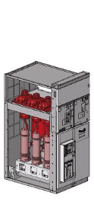

1 Panel type SBC, LSC2A - Switch-disconnector unit with removable circuit-breaker - 750 mm

1 Cable entry for 1-phase cables up to 300 mm2

1 Voltage presence indicator with fixed lamps type VPIS

1 Anti condensation heater for cable compartment 230VAC

1 Earthing switch, full making capacity

1 Interlocked with Gsec

1 GSec - Three position switch-disconnector and with earthing switch and 1-spring operating device

1 Auxiliary contacts for switch-disconnector closed

1 Auxiliary contacts for earthing switch

- Set of 4 pcs change-over

- Set of 4 pcs change-over

1 Wide low voltage compartment for 750 mm functional unit

1 Necessary auxiliary circuit and MCBs are automatically included as per factory stds according panel configuration/selections.

1 Circuit breaker, 24kV, 630A, 16kA

1 Closing push button

1 Opening push button

1 Mechanical signalling device for closing springs

1 Mechanical signalling device for circuit breaker

1 Operation counter

1 Set of 5 auxiliary contacts

1 Lock push buttons

1 Shunt opening release 230 VAC

1 Shunt closing release 230 VAC

1 Spring charging motor 230 VAC

1 Cover for open/close push buttons

3 CURRENT TRANSFORMER, …../5-5A,0.5 5P10+C (set 1, Ip=….. A, Polarity: P1 on busbar side)

3 Core1 : Is=5A; 10VA; 0.5; fs

3 Core2 : Is=5A; 7.5VA; 5P10

3 Voltage divider

Frequency: 50Hz

Additional Data

1 PUSH BUTTON RED

1 PUSH BUTTON GREN

1 PILOT LIGHT RED (230V AC)

1 PILOT LIGHT GREEN (230V AC)

1 SELECTOR SWITCH LOCAL-REMOTE

1 CURRENT TEST BLOCK

1 RELAY REF601 IEC

# General remarks and clarifications

1) Both the offered equipment and switchboards are in accordance with the international IEC Standards.

2) The switchboard will be tested in the ABB workshops, according to the normal tests for acceptance of switchboards foreseen by IEC Standards.

3) Our quotation does not include:

* Power cables terminals and connections
* Erection and commissioning
* On site tests
* Spare parts

**Available as option if required and listed in “Switchgear Accessory” chapter if included.**

**Auxiliary Voltage will be the same of the Switchgear.**

**If Included, must be considered for replacement of an exixsting equipment and not for future additions not according with delivered product.**

**Installation shall be done according to ABB Training Level “L1-L2-L3” by qualified person.**

* Engineering and design beyond our scope of supply:
  + relay setting calculations
  + relay protection coordination/selectivity study
  + ITs calculations
  + network study
  + calculation of the short circuit current
  + pressure calculation of the building
  + etc..
* All LV, MV control and power cables out of our panels and related cable sealing
* Means of hoisting for site unloading and transportation
* Factory tests other than routine IEC tests
* Any floor mounting accessory/material (metallic profiles, bolts, nuts, etc.) needed for site erection
* laptop or computer for setting of control and protection unit
* Training
* Civil works
* Any other equipment other than specified in our technical schedule.
* All what is not expressly described (excluding those accessories or devices which are essential for a good performance of the switchboard).

4) The following documentation in English language will be part of our supply:

* For approval (twofold):
  + Front and single line of the switchboards
  + Front of each typical unit
  + Foundation drawings
  + Schematic diagram of each typical unit
* Final as-built (threefold) in addition to the above mentioned documentation:
  + Equipment list
  + Catalogues of the switchboard, and circuit breakers
  + Instruction manuals of the switchboards and circuit breakers
  + Catalogues of the protection relays

We engage ourselves to submit to your technicians the as-built documentation at the moment of the acceptance test of each lot of the supply in order to get your formal acceptance of the same.

Relevant documentation will be sent to you by courier within 10 working days from the shipment of the lot itself.

In case such documentation will be considered by you defective and/or not sufficient you should communicate us, by registered letter, within 15 days from the receipt of the documentation itself the degree of in-completion and/or the requested modifications. In case we will not get any comment from you within or later than the 15th day from the receipt of the documentation it is agreed that you could not oppose any argument about the in-completion of the documentation in order to the observance of agreed term of payment.

5) The treatment and painting cycle will according to our standards and the colour of external painted surfaces will be RAL7035 (if not differently written into additional data section).

6) Our internal quality system is certified as per UNI EN ISO 9001 (ISO 9001).

7) Our quotation has been processed considering the following documentation:

With the following remarks and/or specifications:

# Routine Tests and Factory Acceptance Test (FAT)

Factory Acceptance Test procedure for Medium Voltage air insulated switchgear for primary distribution.

**FAT is optional and shall be ordered; check Cap 1.1 General Data to see if FAT is included.**

**A1. Factory Acceptance Test procedure**

A1.1 General

A1.2 Routine Test

**A2. Routine Test Report**

**A1. Factory Acceptance Test procedure**

**A1.1 General**

All the panels related to the Customer purchase order are fully tested according to ABB document nr.IO 015 en “Internal routine test procedure for medium voltage air insulated AC metal-enclosed switchgear and controlgear”.

The Factory Acceptance Test (if ordered) is performed in order to give evidence of the following points:

• Compliance with the Customer order.

• Correct functionality of the system.

It is established as criterion that the tests mentioned at the chapters nr.1.2.2, 1.2.3 and 1.2.4 will be verified only on typical panels of the Customer order, giving to the customer the possibility to decide which are the typical units to be tested.

**A1.2 Routine Test**

Activities considered for the Routine Tests are:

* 1. Visual inspection and check of dimensions
  2. Mechanical operation tests
  3. Electrical - logic operation and wiring test
  4. Check of measurement and protection circuits
  5. Power frequency voltage insulation test of the aux. circuits
  6. Power frequency voltage insulation tests of main circuits
  7. Measurement of the insulation resistance on main circuits
  8. Measurement of the ohmic resistance of the main circuits

Activities repeated at the FAT (if ordered) with Customer attendance are:

1. Visual inspection and check of dimensions
2. Mechanical operation tests
3. Electrical - logic operation and wiring test
4. Check of measurement and protection circuits

Following detailed list of the activities.

**A1.2.1 Visual inspection and check of dimensions**

1. Check that the units are built according to the purchase order and project requirements.

2. Check of the correspondence of all components installed according to the switchgear drawings.

3. Check that the wording and positioning of the data plates comply with the drawings.

4. Check that the painting complies with the requirements.

**A1.2.2 Mechanical operation tests**

1. The purpose of these tests is to carry out the mechanical operation tests on the typical panels in the following way:

2. Switching devices shall be operated, removed and inserted in order to check the interlocks

3. Check of the correct accessibility to the circuit breaker compartment.

4. Check of the correct closing of the doors.

5. Check that circuit breaker is prevented from racking in and out when it is closed; the racking in and out is allowed only with the circuit breaker in open position.

6. Check that the circuit breaker (*) is prevented from closing during racking in and out.

7. Check that the circuit breaker is prevented from racking in when the door is open (Optional).

8. Check that the door is prevented from opening when the circuit breaker is in racked in position (Optional).

9. Check that the circuit breaker is prevented from racking in when the earthing switch is closed.

10. Check that the earthing switch cannot be closed when the circuit breaker is racked in.

11. Check that the cable compartment door cannot be opened if the earthing switch is open (Optional).

12. Check that the earthing switch cannot be opened if the cable compartment door is open (Optional).

13. Check of the interchangeability of the moving part of circuit-breakers that have the same rated current.

14. Check of the functionality of the key interlocks, if provided, and the difference in code (Optional).

15. Check of the signalling of the mechanical indicators.

16. In case of V.T.’s truck in the circuit breaker compartment (Metering or Bus Riser units), check of the correct insertion of the main contacts.

(*) The test shall be carried out in the same way in case of other removable apparatus (e.g. contactor).

**A1.2.3 Electrical - logic operation and wiring test**

The purpose of these tests is to carry out the electrical operation tests on the typical panels in the following way:

1. Check of the electrical functionality with reference to electric drawings.

2. Check of logic functions of signalling, blocking and operation in compliance with the logic diagram.

**A1.2.4 Check of measurement and protection circuits**

The purpose of these tests is to carry out the measurement and protection circuits on the typical panels in the following way:

1. By means of primary current injection:

a) The correct ratio of the current transformers.

b) The measurements of instruments and transducers.

c) The tripping of the protection relays.

d) have to be verified.

2. By applying a secondary voltage:

a) The voltmeter circuits.

b) The measurements of instruments and transducers.

c) The tripping of the protection relays.

have to be verified.

By applying a low primary voltage (110 V three-phase), the correct electrical connection of the VT’s has to be verified.

**A2. Routine Test Report**

At the end of the Factory Acceptance Test the routine test report will be issued reporting:

• Tests performed during Factory Acceptance Test.

• Tests performed during the internal assembly process.

The report will be signed by all the FAT participants.

# Service Proposal

## Service

The Service offers worldwide services for maintenance, retrofitting, supply of spare parts, training, erection and commissioning of medium voltage switchgear. The Service team offers services in close collaboration with the worldwide ABB Service network. The main activities are described below. Please contact your local ABB Service center for further information regarding the equipment you have installed. The “Customer Service Plan” is a package of personalized services for after-sales support. These services range from basic product support to full life cycle management of an installation. Customers can select the mix of services which best suits their specific needs. All the services offered apply to both the switchgear and the apparatus and are grouped into the five main categories specified below.

## Installation Services

**Installation**

The installation service for our range of medium voltage apparatus and switchgear includes:

* decommissioning and removal of old switchgear
* site supervision
* installation and assembly of new apparatus.

**Commissioning**

Qualified technicians perform commissioning of the switchgear and protection and control systems, as part of our supply, and this includes:

* simulation commissioning to check operation of the protections and controls.
* commissioning with energization of the apparatus.
* supervision during start-up of the installation.

## Corrective Services

**Spare Parts**

ABB keeps a comprehensive stock of spare parts both for products in production and phased-out products. The spare parts, of single components and complete systems, can also be available at the Service units of the whole ABB network. Spare parts can be purchased in the following ways:

* directly from our spares warehouse, as and when required.
* by means of a rental formula or by purchasing as spare stock or to be included in a Service contract.

**Workshop and Site Repairs**

ABB Service has fully equipped workshops to repair or refurbish both our own and other ABB companies’ products and switchgear, whether these are products in production or phased-out.

In our workshops we check the conditions of the apparatus and recommend replacement of possible parts and repair according to the original specifications. When suitable, site repairs can be performed on a call out basis.

## Preventive Services

**Preventive Maintenance**

Preventive maintenance is the key to ensure the reliability of installed switchgear. Accordingly, ABB offers a range of preventive maintenance services for our medium voltage products. Planned preventive Service is offered either on a call out basis or as part of a maintenance contract.

**Condition Monitoring**

ABB offers various condition monitoring solutions to measure the main parameters of the installed equipment. The monitoring systems can be fitted to existing apparatus to provide information on the specific conditions of a system. This means it is possible to program plant stoppages for maintenance in a flexible and suitable way.

## Value Added Services

**Site Audits**

As a world leader in the field of medium voltage switchgear with many years of proven experience in different applications, ABB is able to carry out audits on the functional performance of existing apparatus. A typical audit would include:

* checking the documentation of the substation apparatus.
* assessment of the conditions of the apparatus.
* recommendations on maintenance, replacement or retrofitting.

**Consulting Service**

ABB provides a range of consulting services on medium voltage switchgear, which includes:

* recommendations for product application, their upgrading or replacement.
* troubleshooting and diagnostics.
* switchgear decommissioning and disposal.
* personnel training.
* safety.

**Extended Warranty**

Customers can ask for an extended warranty for their medium voltage switchgear. This option can be purchased with new apparatus, or be taken up during and after the period of validity of the original product warranty.

**Retrofit, Life Extension and Upgrades**

In view of the demand for continuous improvement and optimization in managing assets and plants, ABB provides solutions which allow the useful life of medium voltage switchgear to be extended. The options available include:

* complete overhauling and refurbishment of switchgear, in accordance with the original specification with warranty.
* apparatus upgrading by means of retrofitting switching, protection and control devices.
* protection and control device upgrading for the highest levels of the protection and control systems.
* product upgrading to increase safety (for example, by means of installation of electric arc detection devices and systems.

**Service Contract**

To guarantee efficiency of the apparatus installed, we also offer our services on a contract base. Each contract is worked out individually according to the customer’s requirements.

## Training Center

Specific training courses on apparatus, releases and switchgear are organized at the ABB facility in Dalmine.

The courses programs cover description of the products and their components, instructions for use, installation and ordinary maintenance. The courses are held in a classroom for the indispensable theoretical part and to a large extent in the laboratory in front of the apparatus itself, therefore putting the emphasis on direct practical application of the knowledge acquired.

* On request, courses on phased-out products can be organized, adapting the program to specific requirements.
* The participants are given help with the operations for their transfer, hotel bookings, permits from the authorities and for all their logistic needs.
* A certificate of attendance is issued at the end of the course.

Contact us

|  |
| --- |
| PT. ABB Sakti Industri  *Electrification Products Division* |

|  |  |  |  |  |  |  |  |
| --- | --- | --- | --- | --- | --- | --- | --- |
| **PT. ABB Sakti Industri** World Trade Center III, 25th-26th Floor *Jl. Jend. Sudirman Kav 29-31* Jakarta, 12920 - Indonesia Phone : +62 21 2551 5555  Fax : +62 21 2551 5566 [www.abb.com](http://www.abb.com)  Contact Center :  Phone: +62 21 8060 0634  Email: contact.center@id.abb.com |  |  |  |  |  |  |  |