Press release
  - ABB launches the New generation PSE softstarter for general purpose applications.
With its high performance, compact design and ease of use, the new generation PSE is the right choice in 80% of full-speed installations. The general purpose PSE is now available on the global market.

PSE is featuring electrical robustness – supports higher starting currents and more frequent starts, allowing customers to push operations harder. A compact design – with its high performance in small footprint, PSE is freeing up scarce and costly floor and panel space. With built-in Modbus communication capabilities, it is easy to integrate the softstarter into any standard production or automation system. Ease-of-use – PSE is so intuitive and easy to use: it takes less than 15 seconds to set it up and start motor. Thanks to a special coated PCB, the PSE is well-protected for secure use in corrosive or humid environments. With an outstanding Torque control that controlling torque to eliminate water hammering, the lifetime and reliability of pumps and pipes are heavily increased.
Softstarter Global Product Line Manager Magnus Tysell says “With our innovation we seek to increase the intelligence of our products and integrate additional functionality and improve our customers’ user experience. The PSE is so intuitive and easy to use, it takes less the 15 second to set it up. With built-in Modbus communication capabilities, it is easy to integrate the softstarter into any standard production or automation system.”
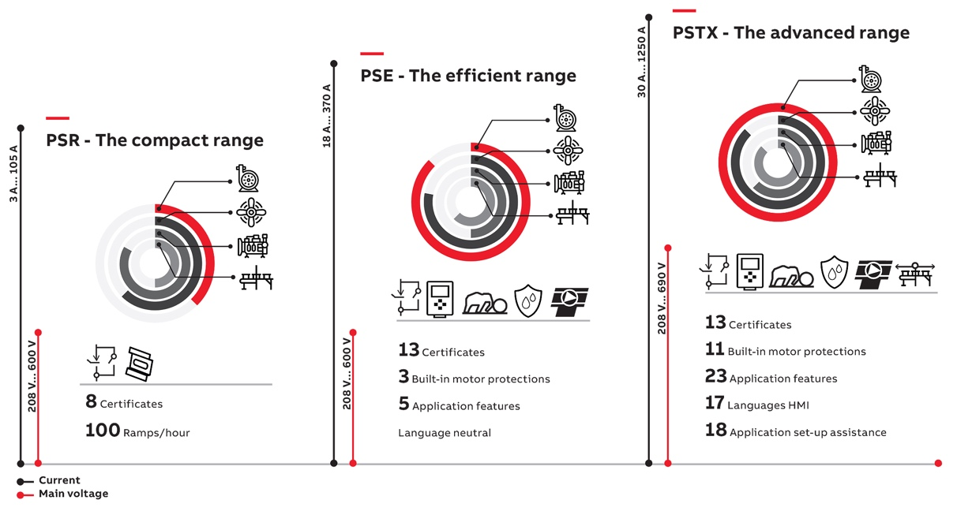
ABB offers three different ranges of softstarters suiting different needs.
ABB(www.abb.com) is a leader in power and automation technologies that enable utility and industry customers to improve their performance while lowering environmental impact. The ABB Group of companies operates in around 100 countries and employs about 140,000 people. For help with any technical terms in this release, please go to: www.abb.com/glossary.

