Email title: Marrette® 933™ PRO-BLU™ 2022 Promotion Begins September 15

Dear ______________,

The annual promotion for our Marrette® 933TM PRO-BLUTM wire connectors returns on September 15, 2022.

This year, we are offering instant in-pack gifts to contractors who purchase the following Marrette® PRO-BLU^{MC} packaging format from a participating distributor.

When purchasing a BARREL (933BAR – 25,000 units) → 4 safety glasses with integrated LED lights and 3 headlights
When purchasing a FLIP-PAK (933BK – 10,000 units) → 2 safety glasses with integrated LED lights and one headlight
When purchasing a JAR (933JAR-1000 – 1,000 units) → one pen size flashlight

You can view the promotional video by clicking on the image below.

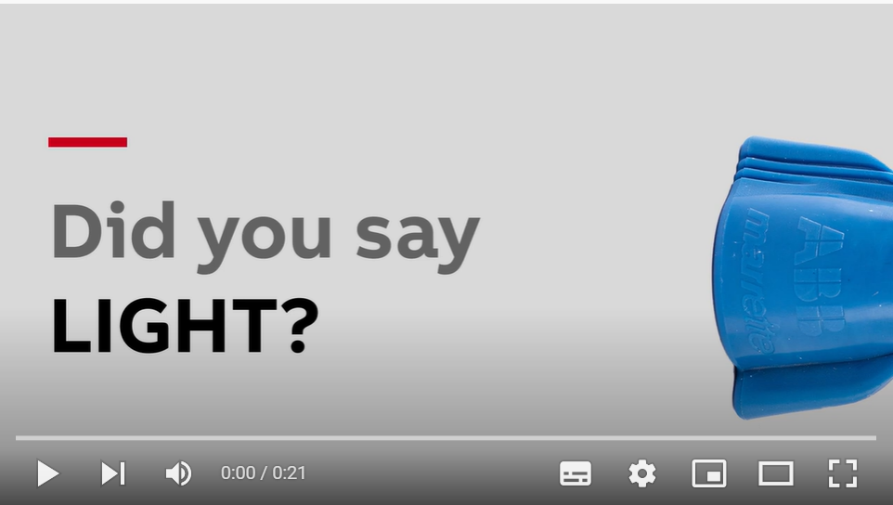

Full details of the promotion can also be found on this web page.

Marrette® PRO-BLUTM wire connectors are designed and manufactured right here in Canada and offer an ergonomic design that reduces installation time and finger fatigue. They are ideal for most residential and commercial applications.

If you have any questions, don’t hesitate to contact me.

