Product Overview
ACQ580

The ACQ580 is the latest addition to the ABB drives portfolio. This robust, compact and energy efficient drive is designed for securing the flow of water and wastewater in your pumping system.

Secure the flow
The ACQ580 variable frequency drive (VFD) delivers innovative pumping features for the water
and wastewater industry. Primary Setting menu and assistants simplifies commissioning, setup and daily control. Embedded water and wastewater application features create an intuitive environment for users and dedicated pumping features enhance the performance of the pumping system.

Speak the language
Leveraging clear, water industry terminology, the control panel enables operators to efficiently interface with the drives in terms they use every day. The optional Bluetooth control panel allows for wireless commissioning and monitoring.

Feel the Power
ACQ580 drives are designed for customers who value reliability, high quality, and robustness. With embedded pump functionality, the ACQ580 keeps the pump system operating optimally and efficiently. Product features, such as coated boards and optional compact UL Type 12 enclosures, make the ACQ580 suitable for harsh conditions.

All ACQ580 drives are current rated devices. The HP ratings provided are for reference only and are based on typical 4-pole motors at nominal voltages (NEC Table 430.250). If full motor torque is required, ensure the drive has a continuous current rating equal to, or greater than the full load amp rating of the motor.

The ACQ580 is available in both normal and heavy-duty ratings. Normal duty ratings provide a 110% short term overload rating for one minute every ten minutes. Heavy duty ratings provide a 150% short term overload rating for one minute every ten minutes. All ACQ580 drives and their protective functions are thoroughly tested for optimal performance.

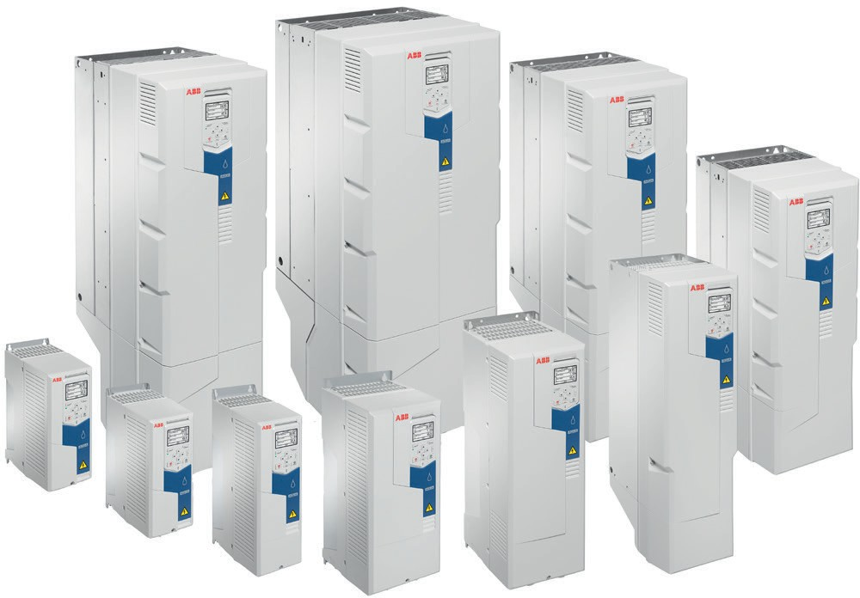

Control panel features

The ACQ580 Assistant Control Panel features:
- An intuitive interface
- Primary Settings menu to simplify drive commissioning
- A real Time Clock
- Diagnostic and Maintenance functions
- A full graphic display, including chart, graph, meter options
- 21 editable home views
- A USB interface for PC and tool connection
- Alpha-numeric parameters
- A choice of 14 languages
- A dedicated Help key
- Four user sets
- The ability to store parameters in control panel memory for later transfer to other drives or for backup of a particular system.
- A back-up and restore feature
  - Parameters and/or motor data
  - Automatic back-up two hours after parameter change
- A modified parameter display
  - Creates unique short menu
  - Shows parameters that differ from default

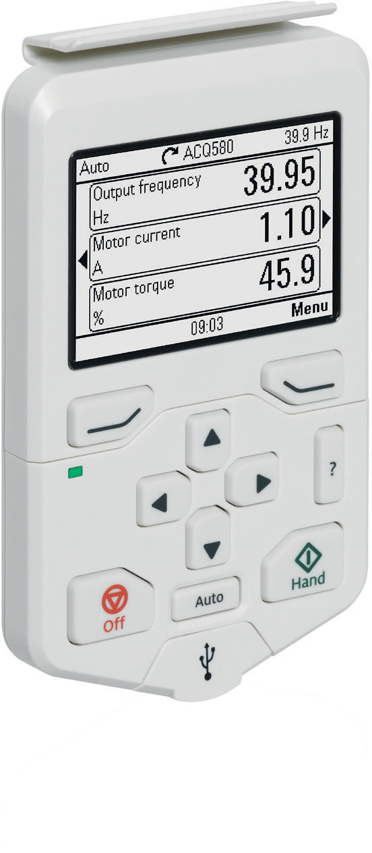

Feature overview

Water Application Functions
Intelligent multi-pump control
Quick ramps
Sleep boost
Auto change
Level control
Soft pipe fill
Sensorless flow calculations
Pump cleaning
Pump priority
Two independent adjustable accel/decel ramp
Two or three wire start/stop control
Motor preheating
PID controllers for motor and process
Motor flying start Process PID control
Coast to stop Ramp to stop
Real-time clock (scheduling)
Run permissives
Start interlock delayed start
PID controller parameters
PID sleep / wake-up
Set point controllers (process and external)
Dry pump protection
Dry run protection
Pressure protection
Inlet pressure protection
Maximum pressure protection
Minimum pressure protection
Flow protection
Start-up assistants
Primary settings for ease of use
Sophisticated process control
Energy optimizer and calculator
Diagnostic assistant
Built-in and stand-alone process control
PID loop
Load profile
Adaptive programming
Motor control features
Scaler (V/HZ) and vector control Motor
ID run
U/F ratio
- Linear
- Squared
Energy optimization IR compensation
Slip compensation
Critical frequency lockout bands
Flux braking
Communication Protocols
Standard Modbus RTU (EIA-485)
Available optional protocols:
- Ethernet I/P
- DeviceNet
- Modbus TCP
- Profibus-DP
- PROFINET

Control panel functions / features
First start assistant
Primary settings for W/WW applications
Hand-Off-Auto operation
Full-graphic and multi-lingual display
Parameters are alpha-numeric
21 editable home views
Four user sets
Dedicated Help key
Backup/restore (read/write) of parameters and
motor data
Automatic back-up two hours after parameter change
Parameters stored in control panel memory
Standard USB interface for PC and tool connection
Operating data display:
- Output frequency (Hz)
- Speed (RPM)
- Motor current (A)
- Calculated % motor torque
- Calculated motor power (kW)
- DC bus voltage (V)
- Output voltage (V)
- Heatsink temperature
- Elapsed time meter (resettable)
- kWh (resettable)
- Input / Output terminal monitor
- PID actual value (feedback)
- Error fault text
- Warning text
- Three scalable process variable displays
- Real-time clock
- User-definable engineering units
Modified parameter display
- Creates unique short menu
- Shows parameters that differ from default
Diagnostic and maintenance functions
Supports 14 languages
Protective Functions
AI Supervision
Overvoltage
Undervoltage
Drive temperature
Earth (ground) fault detection
Emergency stop
Local control loss detection
Motor phase loss detection
Overcurrent protection
Overspeed protection
Safe Torque Off detection
Short circuit
Stall protection
Supply phase loss detection
Swapped supply and motor cabling
Motor overtemperature protection (UL508C)
Input and Output switch supervision
Underload supervision
Overload supervision
Loss of reference
Panel loss
External events
Current limit regulator
Transient/ surge protections (MOV and Choke)

Control terminals

Default I/O connections
This is the default configuration of control connections for water and wastewater applications.

Default control connections for water applications

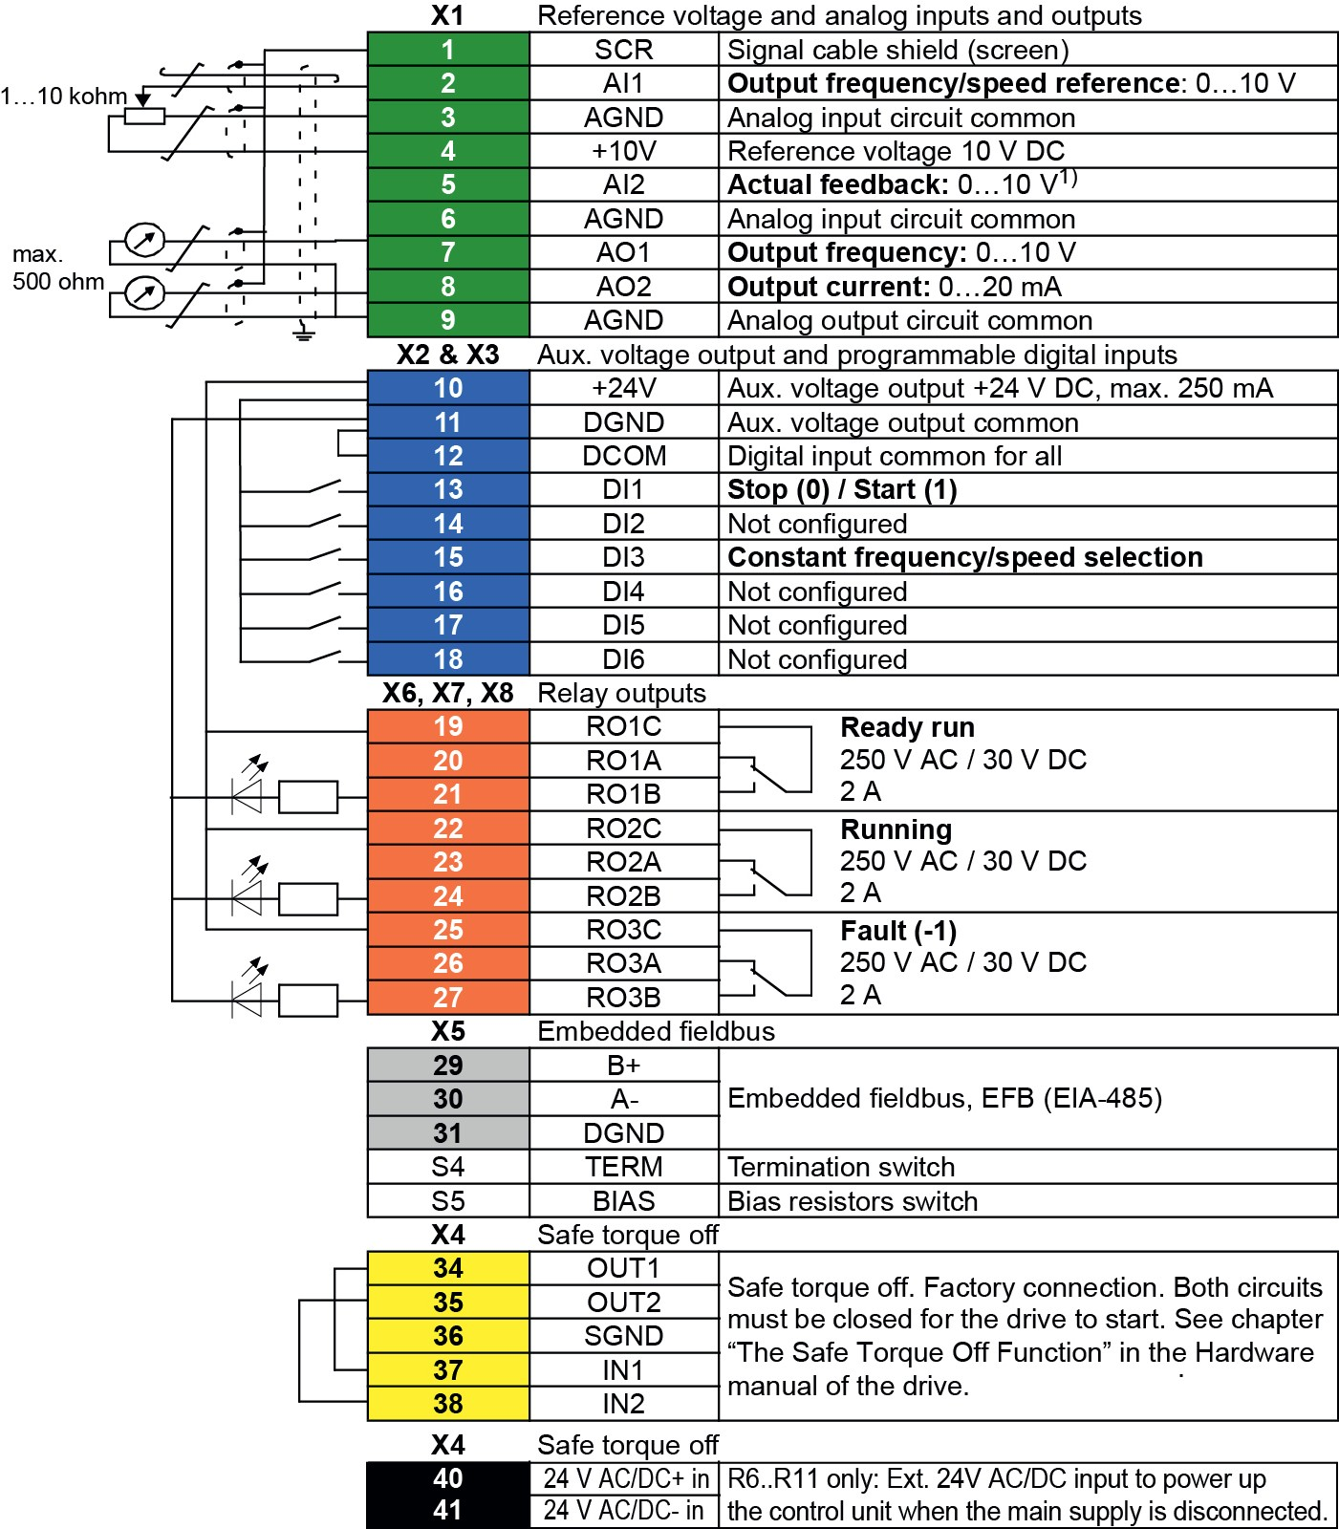

Technical specifications

Supply connection
Voltage and power range  Input voltage (U1)  ACQ580-01-xxxA-2  ACQ580-01-xxxA-4  ACQ580-01-xxxA-6 | 208-240 V  440-480 V  525-600 V
Input voltage tolerance | 10% / -15%
Line Limitations | Max ±3% of nominal phase to phase input voltage
Power Factor (cos Φ) at nominal load
ACQ580-01 | 0.98
Efficiency at rated power
ACQ580-01 | 98%
Power Loss | Approximately 2-3% of rated power
Motor connection
Supported motor control | Scalar and vector
Supported motor types | Asynchronous motor, permanent magnet motor (vector), SynRM (vector)
Voltage | 3-phase, from 0 to supply voltage
Frequency | 0 to 500 Hz
Short Term Overload Capacity Variable Torque | 110% for 1 min/10min
Peak Overload Capacity  Variable Torque | 1.35 for 2 second  (2 sec / 1 minute)
Switching Frequency | 2, 4, 8 or 12 kHz (Up to 150 Hp);  1 or 4 kHz (Over 150 Hp),  Automatic fold back in case  of overload
Acceleration/Deceleration Time | 0 to 1800 s
Short Circuit Current Rating | 100 kA (UL) with fusing
External power supply
ACQ580-01, R6-R9: Standard | 1.50 A at 24 V AC/DC  ±10% / 36W
ACQ580-01, R1-R5: Optional card | 1.04 A at 24 V AC/DC  ±10% / 25W
Safety
Safe Torque Off (STO)
STO Standard Input | 17...30 VDC, 55mA
Degree of Protection
Degree of protection (IEC/EN 60529)
ACQ580-01 | IP21, IP55
Enclosure types (UL 508C/61800-5-1)
ACQ580-01 | UL (NEMA) Type 1 & 12

Inputs and outputs
2 analog inputs | Selection of Current/Voltage input mode is user programmable.
Voltage reference | 0 (2) to 10 V, Rin > 200 kΩ
Current reference | 0 (4) to 20 mA, Rin = 100 Ω
Potentiometer reference value | 10 V ±1% max. 20 mA
2 analog outputs | AO1 is user programmable, for current or voltage. AO2 current
Voltage reference | 0 to 10 V, R_{load}: > 100 kΩ
Current reference | 0 to 20 mA, R_{load}: < 500 Ω
Applicable potentiometer | 1 kΩ to 10 kΩ
Internal auxiliary voltage | 24 V DC ±10%, max. 250 mA
Accuracy | +/- 1% full scale range at 25°C (77°F)
Output updating time | 2 ms
6 digital inputs | 12 to 24 V DC, 10 to 24 V AC,  Connectivity of PTC sensors supported by a single digital input.  PNP or NPN connection  (5 DIs with NPN connection).  Programmable
Input Updating Time | 2 ms
3 relay outputs | Maximum switching voltage  250 V AC/30 V DC.  Maximum continuous current 2 A rms.  Programmable, Form C
Contact material | Silver Tin Oxide (AgSnO₂)
PTC, PT100 and PT1000 | Any of the analog inputs, or digital input 6, are configurable for PTC with up to 6 sensors.
Adjustable filters on analog inputs and outputs
All control inputs isolated from ground and power
Operation
Air Temperature | -15 to +40 ºC (5 to 104 ºF)  50ºC (122ºF) available with derate  0 to -15 ºC (32 to 5 ºF)  No Frost Allowed  Output derated above +40ºC (104ºF)
Installation site Altitude | 0 to 1000 m (3281 ft) above sea level  Output derated above  1000m (3281 ft) up to 4000m (13123ft)
Relative Humidity | 5 to 95%  No condensation allowed  Maximum relative humidity is 60% in the presence of corrosive gasses
Atmospheric pressure | 70 to 106 kPa (10.2 to 15.4 PSI)  0.7 to 1.05 atmospheres
Vibration | Risk category IV Certified (IBC 2018)

Environmental protections
Chemical Gasses | Class 3C2 (UL Type 1 , IP21)  Class 3C2 (UL Type 12 , IP55)  Note: Conformal coated PCBs
Solid Particles | Class 3S2  No conductive dust allowed
Pollution degree  (IEC/EN 61800-5-1) | Pollution degree 2
Product Compliance
Standards and directives
Low Voltage Directive 2006/95/EC
EMC Directive 2004/108/EC
60721-3-3: 2002
60721-3-1:1997
Quality assurance system ISO 9001 and
Environmental system ISO 14001
CE, UL, cUL, CSA and EAC approvals
Galvanic isolation according to PELV
RoHS2 (Restriction of Hazardous Substances)
EN 61800-5-1: 2007; IEC/EN 61000-3-12;
EN 61800-3: 2017 + A1: 2012 Category C2
(1st environment restricted distribution);
Safe torque off (EN 61800-5-2)
Seismic (IBC, OSHPD) - Coming 2019
EMC  (according to EN61800-3) | Class C2 (1st environment, restricted distribution)
Available Options
External 24V AC/DC and digital I/O extension (2xRO and 1xDO) (CMOD-01)
Additional 115/230 V Digital input (6xDI and 2xRO) (CHDI-01)
Fieldbus Adapter Modules | EtherNet/IP, Modbus TCP, PROFIBUS-DP, PROFINET, DeviceNet
Operation, Programming and Diagnostic Tool | Drive Composer Pro / Entry
Cold configuration tool (CCA-01)
Keypad  Standard  Optional | Hand/Off/Auto  Bluetooth

Storage (in Protective Shipping Package)
Air Temperature | -40 to +70°C (-40 to +158°F)
Relative Humidity | Less than 95%  No condensation allowed  Maximum relative humidity is 60% in the presence of corrosive gasses
Chemical Gasses | Class 1C2
Solid Particles | Class 1S2  Contact ABB regarding Class 1S3
Atmospheric pressure | 70 to 106 kPa  0.7 to 1.05 atmospheres
Vibration (ISTA)  R1...R4  R5...R9 | In accordance with ISTA 1A  In accordance with ISTA 3E
Transportation (in Protective Shipping Package)
Air Temperature | -40 to 70 °C (-40 to 158 °F)
Relative Humidity | Less than 95%  No condensation allowed  Maximum relative humidity is 60% in the presence of corrosive gasses
Atmospheric Pressure | 60 to 106 kPa (8.7 to 15.4 PSI)  0.6 to 1.05 atmospheres
Free Fall | R1: 76 cm (30 in)  R2: 61 cm (24 in)  R3: 46 cm (18 in)  R4: 31 cm (12 in)  R5: 25 cm (10 in)
Chemical Gasses | Class 2C2
Solid Particles | Class 2S2
Shock/ Drop (ISTA)  R1….R4  R5….R9 | In accordance with ISTA 1A  In accordance with ISTA 3E
Vibration (ISTA)
R1….R4
R5….R9

