white paper (august 2021)

Sustainable Services
  - How Life Cycle Services is a Sustainable Value Proposition

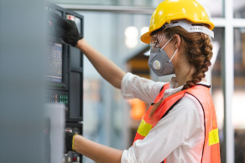

Sustainability and ABB as an organization

Sustainability Strategy 2030 (1)
The need for action on climate change is becoming ever more urgent. The hottest years on record have all occurred since 1998 and they are increasing in frequency. At the same time, overuse of the earth’s resources and environmental degradation are jeopardizing the health and future prospects of huge numbers of people around the world.
Over the coming decades, the pressure on our environment will only increase: today’s global population of 7.8 billion is expected to expand to 9.7 billion by 2050 (UN). Some 80 percent of people will live in cities, placing enormous burdens on already stretched water, food, energy and transport systems.
With our 2030 sustainability strategy, we are actively enabling a low-carbon society as well as working with our customers and suppliers to implement sustainable practices across our value chain and the lifecycle of our products and solutions. We are equally committed to driving social progress, along with our suppliers and in our communities.
Our sustainability focus is part of ABB’s commitment to responsible business practices, which are at the center of our comprehensive governance framework, based on integrity and transparency. Our framework is underpinned by our five integrity principles in our Code of Conduct, which guides our employees and suppliers to do the right thing and contains a commitment against retaliation.
A key part of our 2030 sustainability strategy is to support our customers and suppliers to reduce their emissions and achieve carbon neutrality in our own operations. Our greenhouse gas emissions reduction targets have been validated by the Science Based Targets initiative as being in line with the 1.5°C scenario of the Paris Agreement.
To ensure that we are focused on achieving our goals, our sustainability targets are integrated into our decision-making processes and we have accountabilities and incentive plans in place to drive action.
Our 2030 commitment (extract):-
- We will support our customers in reducing their annual CO2 emissions by at least 100 megatonnes, equivalent to the annual emissions of 30 million combustion cars.
- We will achieve carbon neutrality across our own operations.
- We engage with our suppliers to extend our impact in reducing emissions across the entire supply chain.
- At least 80 percent of ABB products and solutions will be covered by our circularity approach.
- Zero waste from our own operations will be disposed of in landfills, wherever this is compatible with local conditions and regulations.
- At least 80 percent of our supply spend in focus countries will be covered by a supplier sustainability framework, which will include environment, but also social and governance performance (ESG).
^{x} We have currently identified areas where we can reduce our scope 1 and 2 CO₂ emissions by at least 80 percent and we continuously work on opportunities to do more.
- Taken from ABB corporate website, August 2021 (Sustainability strategy 2030 — Sustainability — ABB Group (global.abb)

Links: Services – Customers – Environment
Sustainability runs through our lives. The media (television, radio, newspapers and magazines as well as web and social media) give continuous coverage around environmental topics. Highlighted by them are all aspects of sustainability, such as pollution, recycling, protection of wildlife, the oceans, rain forests, ice caps and many more. One huge area brought out is the need to reduce carbon emissions, this is recognized by all aspects of society. Among those supporting this drive are: World Leaders, Commercial organizations, (both large and small), Adults, Children, Manufacturers and Consumers – we can see that we all have a part to play.
Individuals are switching to electric cars, insulating their homes, fitting solar panels, reducing unnecessary travel, recycling waste, using ‘bags for life’, etc. meaning that sustainability is being built into everyday life, as a way of life.
ABB as an organization, as can already be seen, has set tough goals in this area. ABB is not alone in this, many of ABB’s customers have set equally challenging, important targets, and they expect to achieve them. We will see later how Services from ABB is a major contributor.
ABB supports its customers to achieve and exceed sustainability targets by way of mutual understanding and benefit, we have the same needs. It is recognized by ABB that increasingly customers may only purchase from suppliers that can demonstrate their sustainability credentials. ABB takes pride in being involved, together with customers, in environmentally driven projects.
Governments and World Organizations are taking a lead with legislation with respect to sustainability and have set rules and standards. Some examples include: -
- RoHs (Restriction of hazardous substances)
- WEEE (Waste Electrical and Electronic Equipment Directive)
- Right to Repair
ABB embeds all the above and more in new product design as well as through a range of novel life cycle services, by means of a durable, repairable, and upgradable oriented approach.
There are cost benefits as a spin off. As we improve the sustainability of equipment and installations, we see a reduction in the total cost of ownership. As we repair, maintain and upgrade parts of, as opposed to entire installations, the safe & efficient operational life is extended, and overall cost falls. This is important to note as a true benefit as it can help when competing for capital budget allocation when looking to make equipment changes.

Service Impact
Sustainability is an enormous topic and it can be difficult to know what to do to make a positive impact. The following section of this white paper describes how ABB services is a powerful contributor. When considering the millions of electrical installations (sub-stations, switchgear, motor control centers, both LV and MV etc.) that exist throughout the world, in various states of its life cycle, ABB services comes into its own by means of extending the operational lifetime of the said equipment.

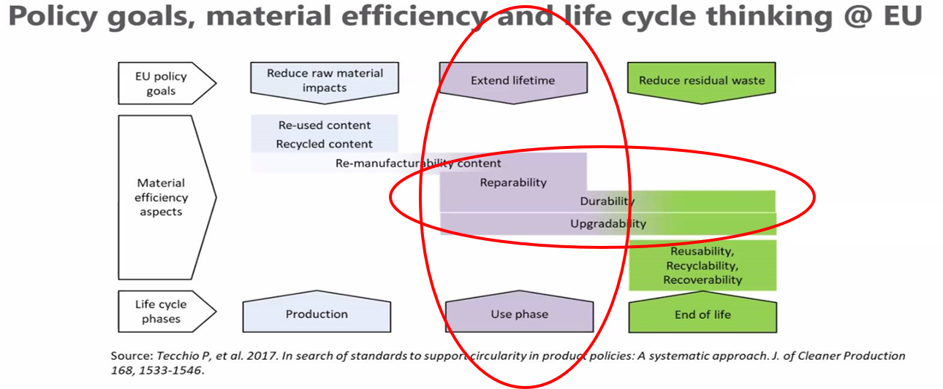

The image above highlights the opportunity for ABB services to reduce the total carbon emissions of a piece of electrical equipment or installation by keeping it running in good, safe, and efficient condition for longer. By following this methodology, fewer items need to be manufactured, delivered, installed, decommissioned, transported again and scrapped.
In tandem with the above sentiment, it is often possible to improve energy efficiency as items (sub parts rather than the entire installation) are upgraded as an additional benefit.
As we improve existing, and develop new life cycle service offerings, sustainability is built into their DNA, just one example is the approach be taken as part of the Relay Retrofit product line. Below is a quote from the product manager: -

‘Sustainability has been taken into account from the beginning of the product design including the pro-environmental manufacturing process, long life time, operation reliability and disposing of the device. The choice of materials and suppliers has been made according to the EU RoHS directive (2011/65/EU). This directive limits the use of hazardous substances. Operational reliability and long life time have been ensured with extensive testing during the design and manufacturing processes. Moreover, long life time is supported by maintenance and repair services as well as by the availability of spare parts. Design and manufacturing have been done under a certified environmental system. The effectiveness of the environmental system is constantly evaluated by an external auditing body. We follow environmental rules and regulations systematically to evaluate their effect on our products and processes.’

Life Cycle Services
ABB Services are based around the equipment or installation lifecycle, this concept has been in place for many years and lends itself naturally to sustainability. The life cycle concept assures equipment can be kept running for the longest possible time. The service concept and product offering mean that overall product life can be extended, safety and efficiency can be maintained (and often improved) and that upgrades can take place to allow for improvements in standards, and new regulations to be applied.
The following sections describe how the service offers contribute to sustainability.

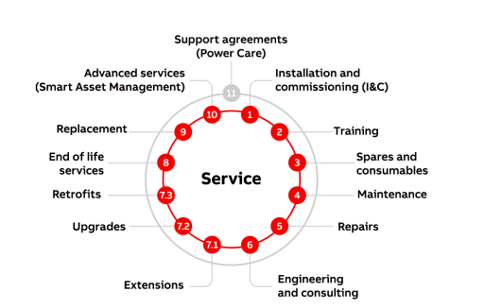

For users with existing equipment and installations an ideal entry point to take advantage of our life cycle services offering and to begin the life extension process is to undertake a life cycle assessment where we can together make an evaluation of the equipment and make recommendations to improve.

Installation & Commissioning and Training
Utilizing ABB’s trained and experience field engineers to fully install or supervise the client teams to install and commission equipment can lead to the following sustainable benefits: -
- Experts can be dispatched from local ABB sites, meaning travel and its associated emissions are minimized.
- Using trained teams with the requisite knowledge can help reduce or even eliminate the need for multiple return visits to site. ABB field engineers have access to all needed documents, parts, specialized tools, and factory/engineering staff for backup.
- ABB commissioning experts can tune and optimize settings and parameters to ensure the equipment is left running in the most efficient way. If further fine tuning or adjustment is needed it is often possible to guide the customer remotely by means of augmented reality and remote connections. This has the potential to completely eliminate travel.
- Customer training can be completed at any time during the equipment lifecycle, but the more knowledge local operators have the less likely is the need for engineers to make journeys to site. This not only helps reduce unneeded journeys but can reduce plant down time and production waste. Training can be delivered online, not just by traditional classroom or workshop based sessions.

Spares, Maintenance & Repairs
Access to spare parts throughout the working life of an installation is key to extending the working time span of the associated equipment. ABB life cycle service engineers have access to genuine spare parts and can often supply them for many years after they are removed from general open sale as a result of continuous product development and improvement. Obsolesce or failure of a part or component need not result in the premature replacement and associated carbon footprint of the complete installation, or large parts of it.
Spare parts can be supplied as packages, advance notice given of life cycle changes and consignment / inventory management are part of ABB’s service offering, either stand alone or as part of a long-term service agreement.
Conducting preventative maintenance is vital to ensure installed equipment runs correctly, safely and in accordance with changing regulations. ABB provides various levels of maintenance services, again available as single events or as a planned occurrence according to a time schedule, or optimized on a condition-based regime.
Should an unexpected repair be needed, ABB can provide skilled service professionals along with the correct parts from local service centers to ensure a fast and efficient repair without creating a large, travel based, carbon footprint.
To further eliminate journeying to site for emergency issues, customers of ABB can self-help to a large degree. A combination of installation specific documentation and training materials are available from an online portal and the use digital remote services as detailed in the following section can contribute to significant sustainability improvements.

Product Highlight – SWAPs, RAISE & CLOSER
SWAPs is a maintenance program based on 5 levels of maintenance (See, Watch, Act, Perform, Secure), where intervals are defined according to the assessment of the equipment environmental and operational conditions, age, previous maintenance performed, and presence of monitoring and diagnostic solutions. The schedule continues until the equipment reaches its end of life, the recommended time for relay and circuit breaker retrofit.

SWAPs provides a complete and optimized maintenance plan for the line-up (aligning activities of the panels, circuit breakers and protection relays) and also distinguishes between the maintenance activities which can be carried out by trained customers (See, Watch, Act) and the ones for which ABB interventions is strongly recommended ( Perform, Secure), to ensure safety and quality of the service activity. The SWAPs plan includes the retrofitting of circuit breakers and relays, which together with the proper maintenance schedule (tailored to the actual conditions) allow the maximum life extension of the switchgear.

SWAPs empowers customers to perform up to 70% of the maintenance activities with their own crew. [The remaining 30% of activities need to be carried out by ABB certified technicians, due to the level of product knowledge required to ensure reliability of the equipment and safety.]
ABB Service is available to inform customers about the actions required to move to the optimal conditions range and thus reducing the number of activities by up to 30% during the switchgear lifetime. This allows an estimated saving of 1.2 tons of CO2 throughout the switchgear lifetime.
When monitoring & diagnostic solutions come into the picture, maintenance intervals can be increased by 30% independently from the conditions – approximately saving an additional 1.14 tons of CO2 throughout the switchgear lifetime.

CO2 savings mentioned result from a reduction in number site visits per installation and therefore reduced travel emissions by utilizing a SWAPs model versus traditional time interval service regime.

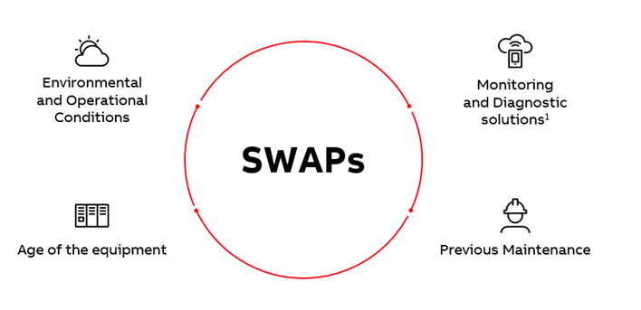

CLOSER (Collaborative Operations for electrical systems) is an application which provides first level support via interactive operational and troubleshooting step-by-step guidance for ABB’s Electrification solutions and products. CLOSER can be accessed by customers 24/7, providing fast and easily accessible guidance with augmented reality, through the different steps of key troubleshooting procedures.

Reduced CO2 environmental impact results due to avoided journeys made by the entirety of ABB service engineers as a whole.

CLOSER allows the ABB ELDS Service crew to make an estimated saving of 142 tons of CO2 per year by halving the trips our field service engineers would traditionally make for first level support interventions.

RAISE is a live video sharing service solution. RAISE reduces the time needed to repair and maintain electrical equipment by allowing ABB experts to use augmented reality to remotely guide field operators on their Android or iOS smartphone, tablet, or via smart glasses and other supported wearables. This speed of resolution is vital in minimizing potentially highly disruptive and costly downtime, especially when critical systems such as data centers or hospital power systems shut down.

RAISE allows an estimated saving of 332 tons of CO2 per year by reducing by 1/3 the total number of trips made by our field service engineers.

Average site interventions’ effectiveness has been increased from 90% to 96% after a first
RAISE assessment of the site conditions – reducing double trips due to missing parts, information, etc.

Safety improvement: the field operator is supported remotely by an ABB engineer with a strong product expertise.

Taking a medium size Data Center as example, RAISE can allow an estimated saving of 125k$ per year related to the direct damage suffered by equipment due to incidents, and approximately 740k$ per year related to consequential damage.

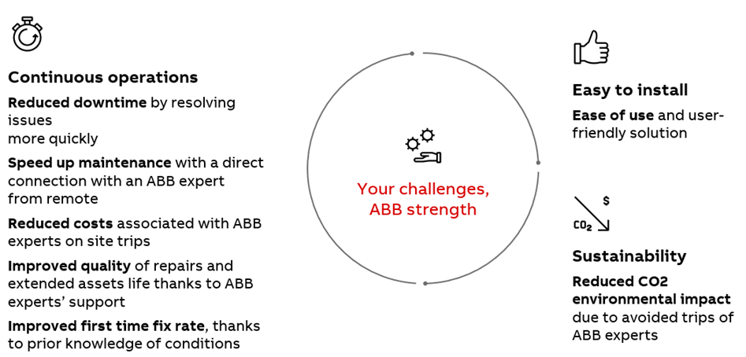

Extensions, Upgrades and Retrofits
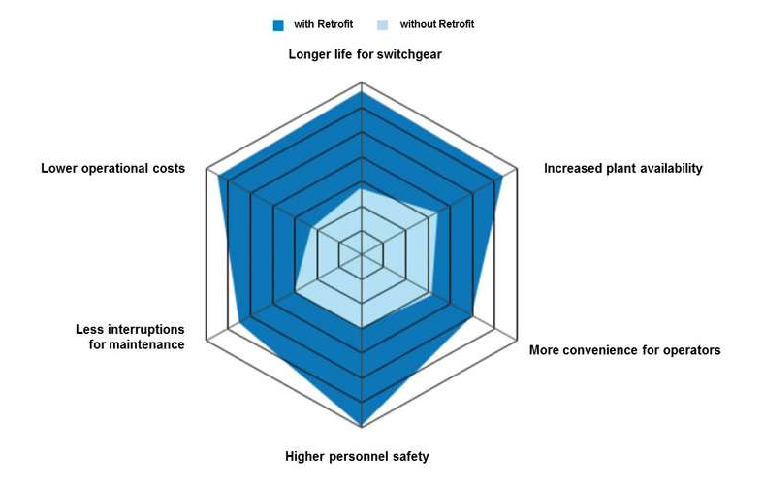

Perhaps the most effective way to extend the safe, efficient, and compliant working life of a system of equipment is by means of extensions, upgrades, and retrofits. When standards, user operating needs or life cycle status dictates modification to the installed equipment is needed, it is far more sustainable to adapt what is already there rather than considering complete replacement.
The diagram above shows very clearly that in an example of MV switchgear, retrofitting the circuit breakers at the end of their serviceable life can more than double the operating life of the overall installation. Our service offering includes many types and forms of circuit breaker retrofit, both LV and MV, in the following section we highlight the OneFit technique.
Life cycle services can provide a range of sustainable upgrade/retrofit options, not limited to the list of examples below: -
- Extensions to allow for plant changes, using original or compatible products to seamlessly integrate new feature and circuits into existing line-ups.
- Upgrade or replace Circuit Breakers to give new features such as communications, remote monitoring, and control.
- Individual drawers/starters in Motor Control Centers can be rebuilt using intelligent starters, or inverters added to allow for energy savings. Reworking the drawers whilst leaving the steelwork and cabling untouched and in place again allows for sustainability improvements and carbon emission savings.
- Upgrades can also include a range of smart digital service deployment that enhances sustainability be reducing the need to be physically present at the equipment (travel and time saving) and to allow optimized safety monitoring, reducing down time and associated environment impact as a result of product failure. Upgrades allow for significant life extension, it’s not uncommon to double to the equipment working life.
Monitoring & Diagnostic solutions can be added to both LV and MV installations to provide on premises continuous monitoring, reporting and predictable failure analysis, all helping to ensure maintenance visits are only performed when needed.
Cloud solutions allow experienced operators to monitor installations remotely round the clock without physical presence from anywhere in the world.
- The Relay Retrofit Program offering includes an entire suite of modern protection relay retrofit upgrade kits deigned to easily and quickly replace old outmoded and disfunction relays in lineups.

Product Highlight – OneFit
OneFit is a unique ABB retrofit concept embedding an integrally safe plug-in technology to easily connect the new breaker to a wide range of existing ABB and non-ABB panels.
Retrofill is a modernization process including the replacement of the circuit breaker and main functional components of the original switchgear.
Benefits are realized both in short and long term perspectives.
Reasonably limited site works, and linked/coordinated planned outages are short compared to the switchgear replacement alternative.
Equipment and spare parts are interchangeable with new ABB extension panels and additional switchgear.
Apparatus are reusable in future ABB replacement switchgear providing an optimized investment to next substation renewal.

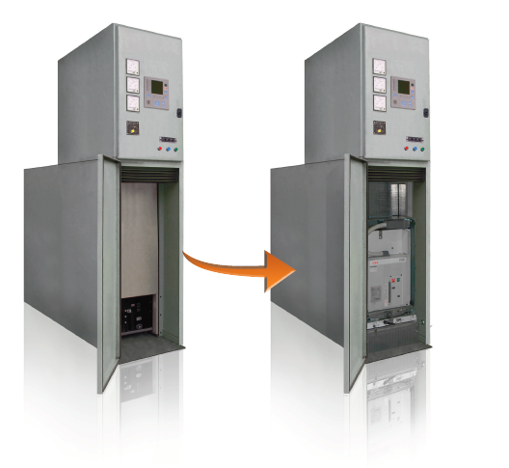

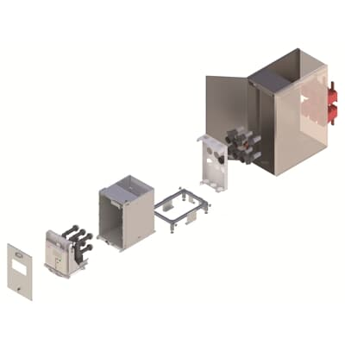

Summary
Life Cycle Services improves sustainability substantially by means of working life extension of installations by way of repairs, preventative maintenance upgrades and retrofits.
Digital and remote services can radically reduce the travel miles and therefore CO2 emissions made by ABB Field Engineers.
For more information on any of our products or services please visit our website for details.
Please do not hesitate to contact us to discuss any aspects of service, particularly how we can help with the achievement of sustainability goals.
https://new.abb.com/service/lifecycle-management?_ga=2.85019161.1469145819.1628851457-358550577.1599052947

Appendix: Awards and Achievements (2020)
Leading technology
- ABB Smart Buildings won three prestigious Red Dot Awards for outstanding design: for the RoomTouch® device, the IP touch 7” visualization panel, and the ABB-free@home® app
- ABB Smart Buildings won a prestigious German Design Award for the IP touch 7” visualization panel
- ABB’s Baldor-Reliance EC Titanium motors won a Silver in the HVAC/R Systems & Equipment category of Consulting-Specifying Engineer magazine’s Products of the Year awards
- ABB Electrification was presented with four prizes at the 2020 China Automation and Intelligent Manufacturing Market Seminar
- The new all-electric Maid of the Mist vessels for touring Niagara Falls, which run on a comprehensive integrated power and propulsion solution supplied by ABB Marine & Ports, were named “Boat of the Year” by the American Ship Review
- ABB was included in the Clarivate list of Top 100 Global Innovators™ 2020, which recognizes companies and institutions that contribute new ideas, solve problems and create new economic value.
- ABB was presented with seven awards in five different categories at the China Automation Industry Annual Conference 2020
- ABB’s Large Motors division’s wind generator technology won Technology of the Year Award in the generator category at the 2020 India Wind Energy Forum
Responsible operations
- ABB received an "A-" at the Leadership Level for its 2020 CDP Climate Change disclosure
- ABB ranked No. 4 in the most sustainable Swiss companies ranking 2020 in Handelszeitung newspaper
- ABB was selected as a member of the FTSE4Good Index Series, marking the 20th consecutive year of recognition for its sustainability performance
- ABB’s Office of Finance won a Vetana Research Digital Leadership Award
- ABB India’s power distribution products factory in Nashik received Gold certification from the Indian Green Building Council (IGBC)
- At the Elmässan trade show in Sweden, ABB Electrification won the Best Electricity News award for its use of recycled plastic packing for the manufacture of electrical installation boxes
- ABB Electrification in China won the 2020 China Finance Summit Corporate Social Responsibility Model award
- In the United States, ABB received the South Carolina 2020 Safety Award from the South Carolina Department of Labor, Licensing and Regulation
- ABB’s site in Nogales, Mexico, received a state-level Green Industry certification and a federal Clean Industry certification

