1
Select (highlight) and copy (ctrl+c) the banner below

2
Go to Outlook mail and click on “New Email”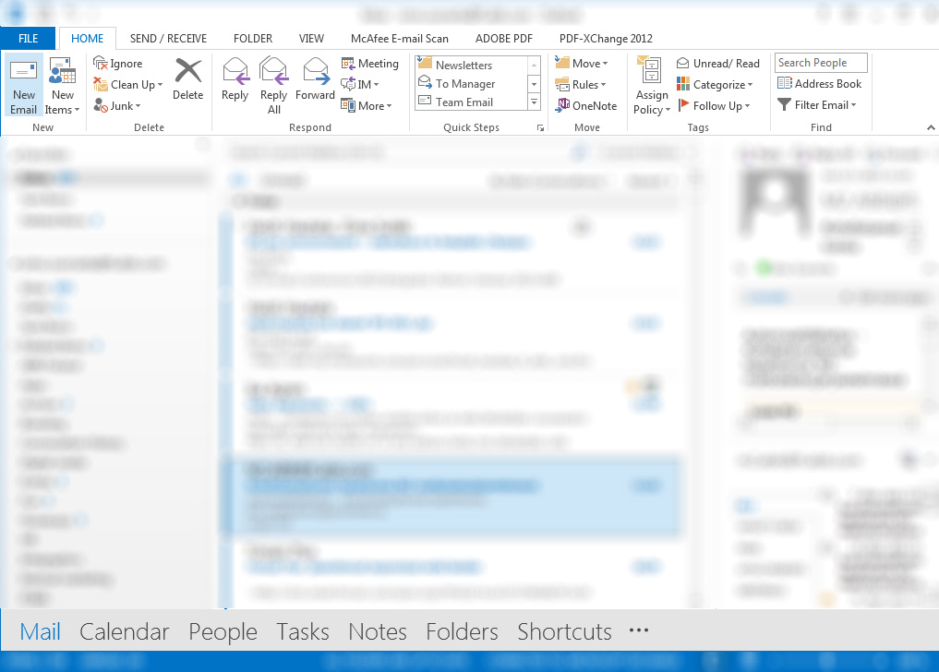

3
Click on “Signature” and continue to “Signatures…”

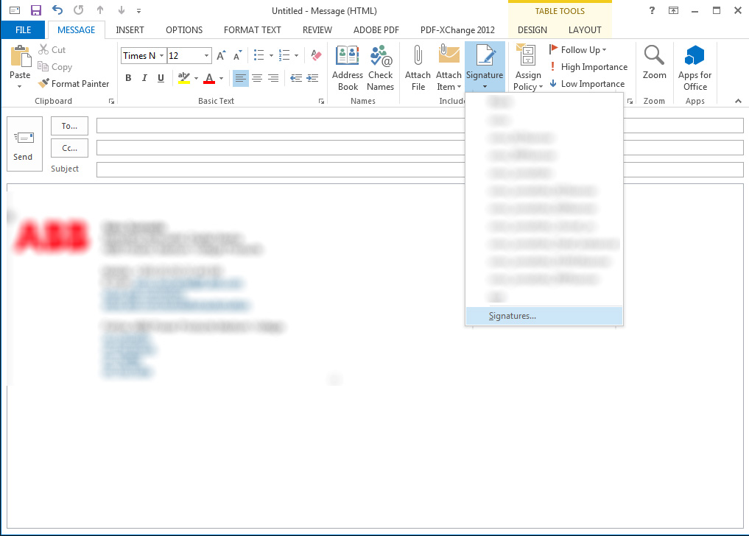

4
Select signature to add the banner to,
scroll down to the bottom and place the cursor to an empty row after your signature

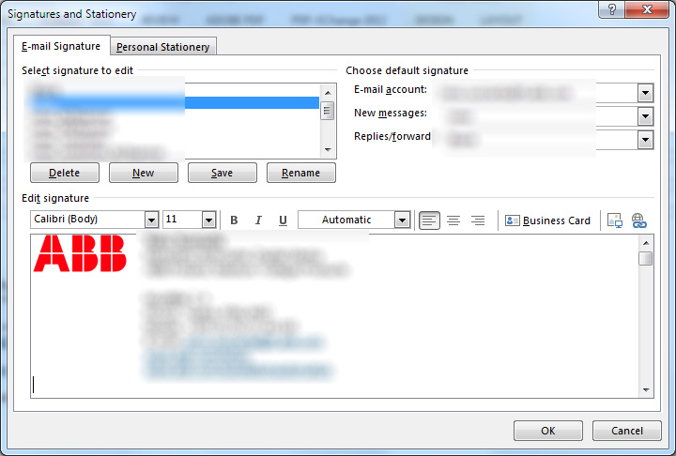

4
Paste (ctrl+v) the banner to your signature

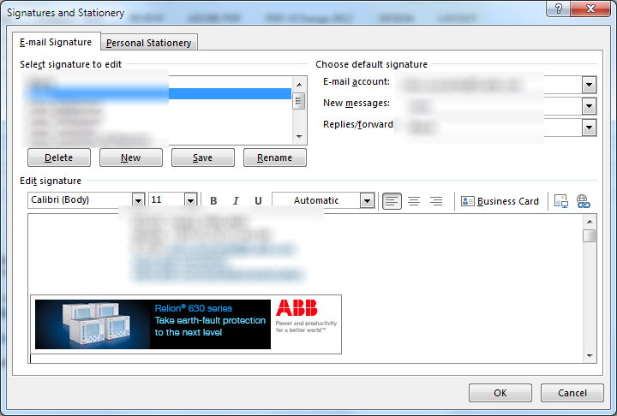

5
Click the hyperlink icon and paste the URL below into the “address” line
https://tnb.ca/en/publications/?id=61
click “OK”

6
Congratulations! You are now ready to
promote ABB.
Your email banner also includes a link to a relevant web page.

