LCA

Communication to the agents
  - Tapa Señalizador 2M ESNIE 2CLP228126N1601

Contents
1. Introduction 2
1.1. Quality and environmental management 2
1.2. Purpose of the study 2
1.3. Eco-designed product 3
1.4. Raw materials used 4
2. Considerations of the eco designed products 4
2.1. Recyclability considerations 4
2.2. Environmental improvements 4
3. Impacts 5
3.1. Methodology and data 5
3.2. Environmental impacts 5
3.3. Comparative 6
4. Conclusions 6

Introduction

Quality and environmental management
Our policy of continuous improvement also requires a demanding and responsible work, which has led to the implementation of the UNE-EN-ISO 14006: Environmental management systems Guidelines for incorporating eco-design in our Quality Management System and Environment.
Eco-design is understood as a process integrated within the design and development that aims to reduce environmental impacts and continually to improve the environmental performance of the products, throughout their life cycle from raw material extraction to end of life.
In order to be of benefit to our organization and to ensure that we achieve our environmental objectives, we carry out eco-design as an integral part of the business operations of our organization.
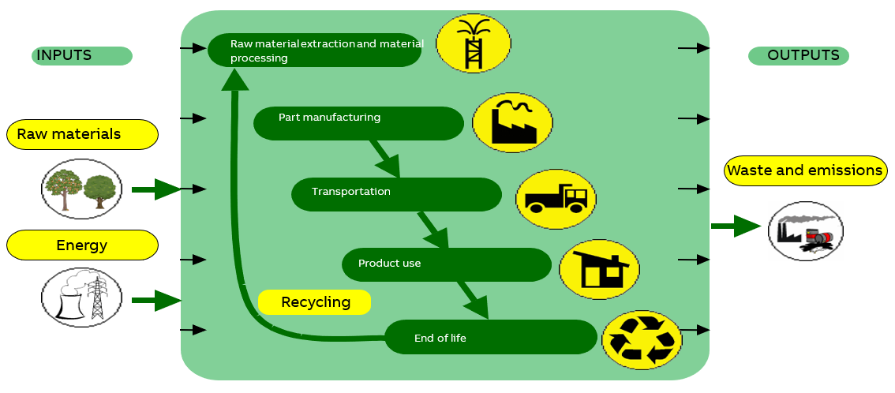

So, in 2007 Asea Brown Boveri, S.A. NIESSEN factory, certify the Environmental Management Design and Development process according to UNE 150301. To subsequently adapt the system to the international standard UNE EN ISO 14006.

ED-0008/2007

Purpose of the study
In this study, the cover of the indicator designed by ESNIE has been environmentally analyzed to seek for an improvement, and it has been compared with the movement detector Mylos to check the reduction in its environmental impact.

Eco-designed product
Representative products | Frames and mounting grids from the ZENIT ITALY range, the indicator ESNIE of 2 modules specifically
Description of the products | PC based frames and mounting grids that provide protection to the indicator ESNIE of 2 modules. Moreover, the location of its production has been changed, which implicate a change in the packaging and transport of the product.
Functional unit | The system is consisting of studying the impact for each ensemble of frame and the mounting grid.

AFTER | BEFORE
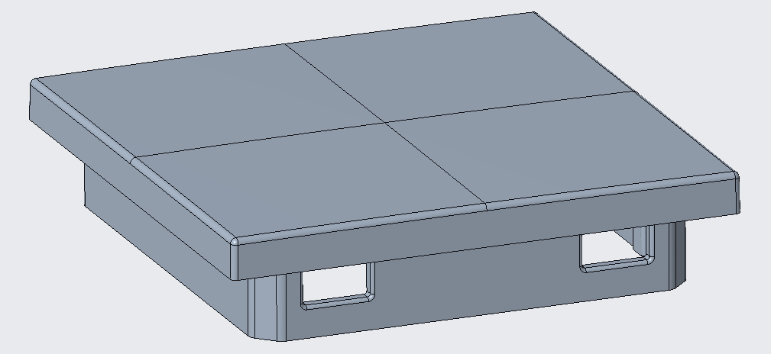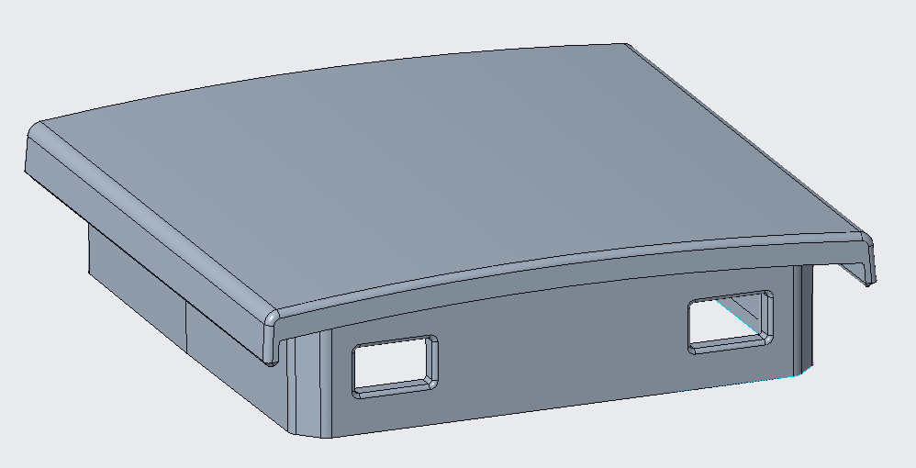
1
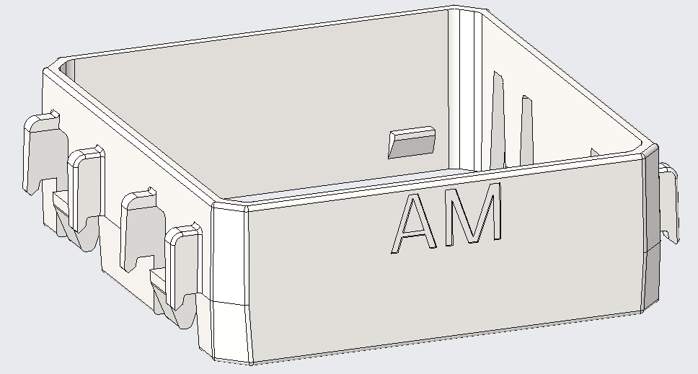
2
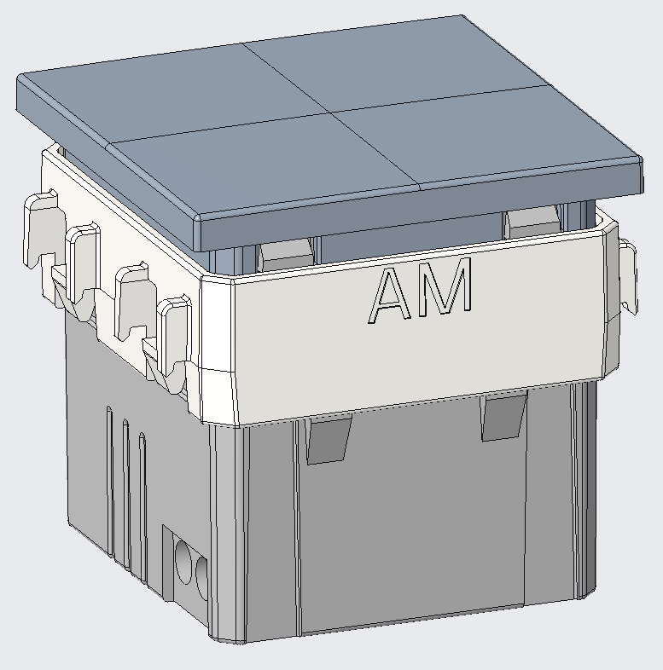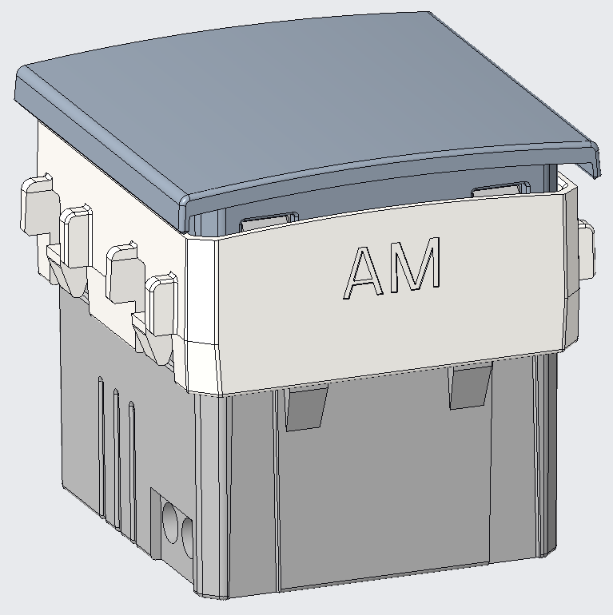
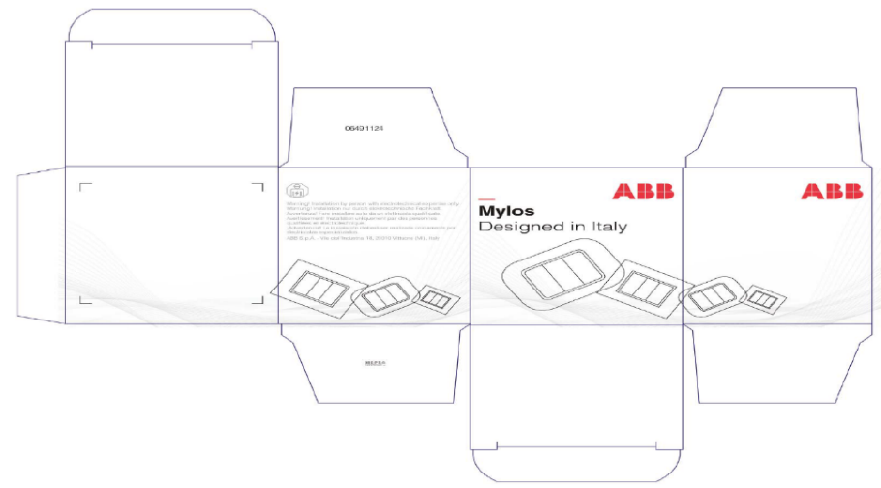
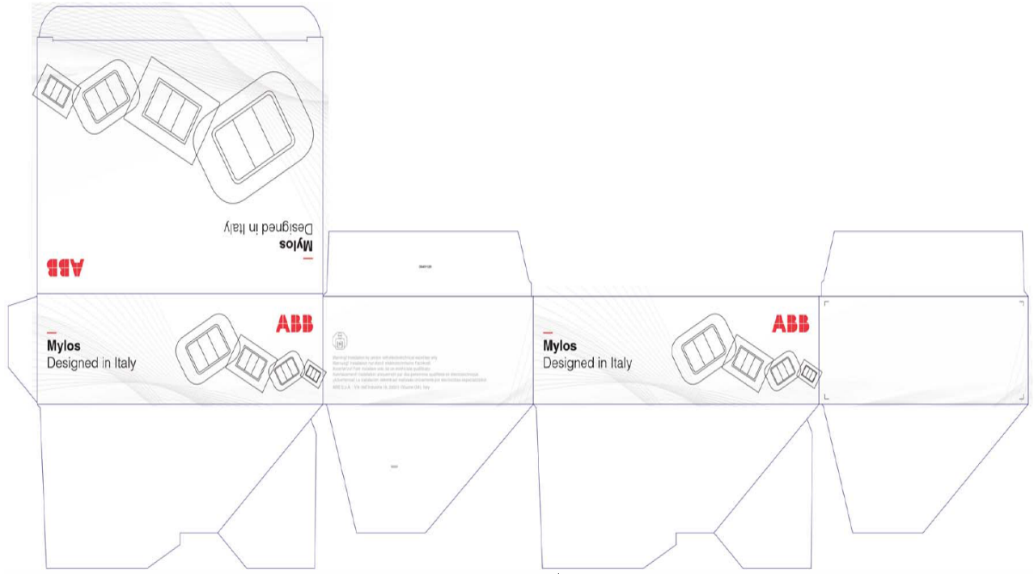

Part | Name | Material
1 | Cover | PC
2 | Mounting grid | PC
3 | Individual packaging | Cardboard
4 | Multiple packaging | Cardboard
In this product, it has been designed a new tape and adaptor for the indicator ESNIE of 2 modules, which replaced a combination of two pieces that needed more material in total. As it has been designed by ESNIE, it has been created the piece that it was bought to protect the sensor and the adaptor for the indicator, but their functionality has not been variated. In this case it remains the quantity of pieces used for the indicator, simply, reducing its weight.
In addition, the transport has been delated, previously the component came from Milan (Italy), while the new component is manufactured in the same place where is mounted.
The packaging has been modified as well as the product manufacturing company has variated.

Raw materials used
As we are studying the impact of the components which are variated, this is the reason why the only material that is used is the one they are made up. In this case, the cover and the mounting grid of the motion sensor is made by the same material, completely of Polycarbonate.
In the packaging, the raw material of the different cardboards is the same, although ESNIE’s material is recycled in a 92%.

Considerations of the eco designed products

Recyclability considerations
-The cardboard packaging is recycled
-The plastics are recyclable, and they include a marking inside (indicating the material they are made of) so they can be disassembled.

Environmental improvements
- Minimum cardboard for recyclable packaging.
-Use of recycled material.
- Minimize the number of components and their weight, thereby savings in energy and raw materials in manufacturing processes.
- Use of water-based paints, avoiding the use of solvents harmful to the environment.
- Product’s transportation has been deleted modifying the manufacturing location to the same place where is distributed.

Impacts

Methodology and data
For this analysis the software Simapro Flow has been used, with the database Ecoinvent 3.6 Cut-off.
The calculations have been made with the methodologies IPCC GWP 100a and CML-IA baseline. With this methodology is studied the abiotic depletion, the air pollution, the ozone layer depletion, the water pollution, the photochemical oxidation, eutrophication, global warming and the acidification.
It is taken into account the entire lifecycle, which include the manufacturing, transport, use and the end-of-life stages. As we are comparing a modification in an element, in many of the stages (use and end of life) there is not any variation, while there is a modification in the raw materials and the elements used for the transport (vehicle and packaging).
The data has been obtained from the company’s data base SAP and different technical datasheet.

Environmental impacts
Using the “CML-IA baseline” method, these compulsory indicators are calculated, which explanations are in the Appendix.
Tapa señalizador 2M Mylos
Impact indicators | Unit | Total | Manufacturing | Transport
Ozone depletion (OD) | kg CFC-11 eq. | 2,307E-09 | 3,251E-11 | 2,274E-09
Photochemical ozone creation (POCP) | kg C₂H₄ eq. | 1,862E-05 | 1,478E-05 | 3,843E-06
Eutrophication (E) | kg (PO₄)³ eq. | 7,057E-05 | 2,564E-05 | 4,493E-05
Global warming (GW) | kg CO₂ eq. | 1,037E-01 | 8,541E-02 | 1,825E-02
Depletion of abiotic resources – elements (ADPe) | kg Sb eq. | 2,881E-07 | 1,621E-08 | 2,719E-07
Acidification of soil and water (A) | kg SO₂ eq. | 3,329E-04 | 2,664E-04 | 6,647E-05
Depletion of abiotic  resources – fossil fuels (ADPff) | MJ | 1,210E+00 | 9,775E-01 | 2,328E-01
Water pollution (WP) | m³ | 3,873E-02 | 9,337E-03 | 2,939E-02
Air pollution (AP) | m³ | 7,897E-01 | 3,556E-01 | 4,341E-01

Tapa Señalizador 2M ESNIE
Impact indicators | Unit | Total | Manufacturing | Transport
Ozone depletion (OD) | kg CFC-11 eq. | 2,307E-09 | 3,251E-11 | 2,274E-09
Photochemical ozone creation (POCP) | kg C₂H₄ eq. | 1,862E-05 | 1,478E-05 | 3,843E-06
Eutrophication (E) | kg (PO₄)³ eq. | 7,057E-05 | 2,564E-05 | 4,493E-05
Global warming (GW) | kg CO₂ eq. | 1,037E-01 | 8,541E-02 | 1,825E-02
Depletion of abiotic resources – elements (ADPe) | kg Sb eq. | 2,881E-07 | 1,621E-08 | 2,719E-07
Acidification of soil and water (A) | kg SO₂ eq. | 3,329E-04 | 2,664E-04 | 6,647E-05
Depletion of abiotic  resources – fossil fuels (ADPff) | MJ | 1,111E+00 | 8,405E-01 | 2,707E-01
Water pollution (WP) | m³ | 5,228E-02 | 8,028E-03 | 4,425E-02
Air pollution (AP) | m³ | 8,365E-01 | 3,057E-01 | 5,308E-01

Comparative

The graphic shows the changes made and the impact differences. In the manufacturing stage, the only factor of the difference is the mass of the element, its reduction is represented in a proportional way in the impact.
In the case of the transportation, in spite of the improvement in this stage reducing the amount of packaging and avoiding the transport, it is not a clear reduction on the environmental impact. This is due to the lack of information about Mylos’ packaging, apart from the cardboard there is not specified extra items (instructions, labels, spacers, …). In this way it is not possible to estimate the sum of all the impacts. Despite of this, ESNIE’s product generates less contamination that come with the global warming.

Conclusions

To sum up, we have a positive result overall. As it has been mentioned in the comparative, we can conclude that in the manufacturing stage a reduction in the raw material used means a decrease of the environmental impact.
However, in the transport there is not a so clear relationship. On the one hand, the impact associated to the vehicle is insignificant next to the rest of the factors. On the other hand, the packaging is variable as each product has a different number of cardboards and extra items.

Note: The presentation of these texts’ wrath according to the medium used (web, catalogs, instructions) so it does not always have this format.

Cecilia de Acha
Development Responsible

03/03/2020

Appendix
Impact indicators | Description | Unit
Global warming (GW) | Indicator of potential global warming caused by emissions to air contributing to the greenhouse effect. Includes fossil and biogenic | kg CO₂ eq.
Ozone depletion (OD) | Indicator of emissions to air that contribute to the destruction of the ozone layer | kg CFC-11 eq.
Acidification of soil and water (A) | Indicator of the potential acidification of soils and water caused by the release of certain gases to the atmosphere | kg SO₂ eq.
Eutrophication (E) | Indicator of the contribution to eutrophication of water by the enrichment of the aquatic ecosystem with nutritional elements, e.g. industrial or domestic effluents, agriculture, etc. | kg (PO₄)³ eq.
Photochemical ozone creation (POCP) | Indicator of emissions of gases that affect the creation of photochemical ozone in the lower atmosphere (smog) because of the rays of the sun. | kg C₂H₄ eq.
Depletion of abiotic resources – elements (ADPe) | Indicator of the depletion of natural non-fossil resources | kg Sb eq.
Depletion of abiotic resources – fossil fuels (ADPf) | Indicator of the depletion of natural fossil resources | MJ (lower heating Value)
Water pollution (WP) | Indicator of the quantity of water necessary to dilute the toxic elements poured into water in all the stages of the product life cycle. | m³
Air pollution (AP) | Indicator of the quantity of air necessary to dilute the toxic elements emitted into the air in all the stages of the product life cycle. | m³

