LCA

Communication to the agents
  - Railway

Contents
1. Introduction 2
1.1. Quality and environmental management 2
1.2. Purpose of the study 2
1.3. Eco-designed product 3
1.4. Raw materials used 5
2. Considerations of the eco designed products 5
2.1. Usage considerations 5
2.2. Recyclability considerations 5
2.3. Environmental improvements 5
3. Impacts 6
3.1. Methodology and data 6
3.2. Environmental impacts 6
3.3. Comparative 7
4. Conclusions 7

Introduction

Quality and environmental management
Our policy of continuous improvement also requires a demanding and responsible work, which has led to the implementation of the UNE-EN-ISO 14006: Environmental management systems Guidelines for incorporating eco-design in our Quality Management System and Environment.
Eco-design is understood as a process integrated within the design and development that aims to reduce environmental impacts and continually to improve the environmental performance of the products, throughout their life cycle from raw material extraction to end of life.
In order to be of benefit to our organization and to ensure that we achieve our environmental objectives, we carry out eco-design as an integral part of the business operations of our organization.
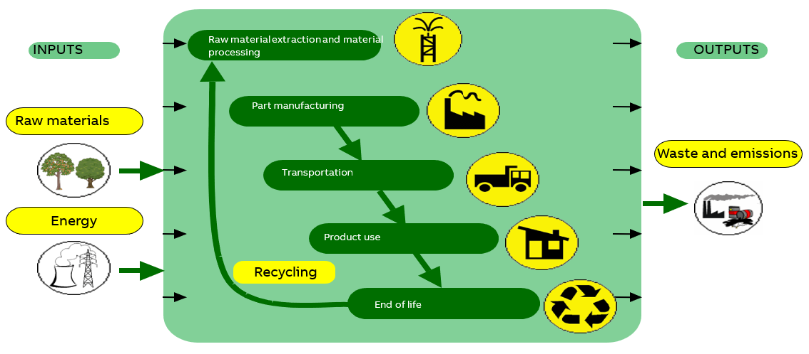

So in 2007 Asea Brown Boveri, S.A. NIESSEN factory, certify the Environmental Management Design and Development process according to UNE 150301. To subsequently adapt the system to the international standard UNE EN ISO 14006.

ED-0008/2007

Purpose of the study
In this study two different flame retardants have been environmentally analyzed. They have been compared when used in a cover for the railway range, where the products are used in trains, so the requirements are quite different.

Eco-designed product
Representative products | Railway flame retardant
Description of the products | Two different flame retardants, V0 and V2, used in railway products
Functional unit | Flame retardant used in different Railway products in order to get the properties required

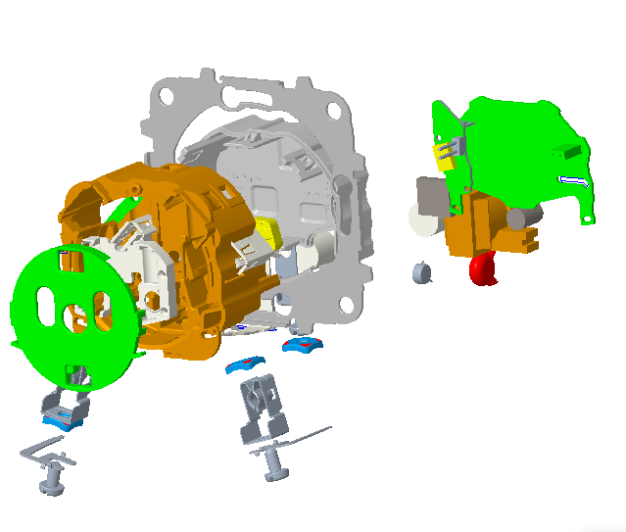
5
2
3
1

Part | Name | Material
1 | TAPA/TAPA AISLANTE | PA 6-6 V0 25FV
2 | TAPA POZO | PC
3 | PERSIANA/TAPA PERSIANA | PA 6-6 V0 15FV
4 | CARCASA | PA 6-6 V0 25FV
5 | PLACA PCB | PCB

Raw materials used

Apart from the main raw material, it has obtained to take out a part of the PCB plate and to save 5 mW of stand-by consumption.

Considerations of the eco designed products

Usage considerations
- Make strong electrical connections; this will prevent heat loss in connections, and unnecessary energy consumption.

Recyclability considerations
-The cardboard packaging is recycled
-The plastics are recyclable, and they include a marking inside (indicating the material they are made of) so they can be disassembled.

Environmental improvements
-Elimination of use of halogenated flame retardants, by using halogen-free materials.
-Minimum cardboard for recyclable packaging
-Minimum number of components, thereby savings in energy and raw materials in manufacturing processes.
-Use of water-based paints, avoiding the use of solvents harmful to the environment.
-The change of components in the electronic circuit achieves a reduction in energy consumption of 3% in the use stage.
-The change of components in the electronic circuit achieves a reduction in energy consumption of 100% in the standby stage.
-The improvement is negative, as the requirements needed in the railway range are more strict

Impacts

Methodology and data
For this analysis the software Simapro 9.1.0 has been used, with the database Ecoinvent 3.6 cut-off.
The calculations have been made with the methodologies IPCC GWP 100a and CML-IA baseline.
It is taken into account the entire lifecycle, which include the manufacturing, transport, use and the end-of-life stages. As we are comparing a modification in an element, in many of the stages (transport and end of life) there is not any variation, while there is a modification in the raw materials and the consumption estimated to the product.
The data has been obtained from SAP and the company’s technical data sheets.

Environmental impacts
Using the “CML-IA baseline” method, these compulsory indicators are calculated, which explanations are in the Appendix.
 | BEFORE
Impact indicators |  | Unit | TOTAL | Manufacturing | Transport | Use | End of Life
Global warming (GW) |  | kg CO₂ eq. | 2,314E-05 | 6,464E-10 | 1,417E-09 | 2,314E-05 | -5,389E-10
Ozone depletion (OD) |  | kg CFC-11 eq. | 1,349E-02 | 5,285E-05 | 9,974E-07 | 1,346E-02 | -1,572E-05
Acidification of soil and water (A) |  | kg SO₂ eq. | 5,710E-02 | 1,133E-04 | 5,428E-06 | 5,716E-02 | -1,858E-04
Eutrophication (E) |  | kg (PO₄)³ eq. | 8,906E+01 | 2,471E-01 | 7,653E-03 | 8,888E+01 | -7,252E-02
Photochemical ozone creation (POCP) |  | kg C₂H₄ eq. | 4,252E-04 | 8,155E-06 | 2,688E-08 | 4,170E-04 | -3,190E-08
Depletion of abiotic resources – elements (ADPe) |  | kg Sb eq. | 2,529E-01 | 7,984E-04 | 2,435E-05 | 2,521E-01 | -3,215E-05
Depletion of abiotic resources – fossil fuels (ADPff) |  | MJ | 1,300E+03 | 2,827E+00 | 1,144E-01 | 1,297E+03 | -6,810E-02
Water pollution (WP) |  | m³ | 6,175E+01 | 2,358E-01 | 4,599E-03 | 6,176E+01 | -2,515E-01
Air pollution (AP) |  | m³ | 5,857E+02 | 1,248E+00 | 1,391E-01 | 2,800E+00 | -1,575E-01

 | BEFORE
Impact indicators |  | Unit | TOTAL | Manufacturing | Transport | Use |  | End of Life
Global warming (GW) |  | kg CO₂ eq. | 2,310E-05 | 9,036E-11 | 1,417E-09 | 2,310E-05 |  | -5,389E-10
Ozone depletion (OD) |  | kg CFC-11 eq. | 1,342E-02 | 4,109E-05 | 9,974E-07 | 1,339E-02 |  | -1,572E-05
Acidification of soil and water (A) |  | kg SO₂ eq. | 5,666E-02 | 7,127E-05 | 5,428E-06 | 5,677E-02 |  | -1,858E-04
Eutrophication (E) |  | kg (PO₄)³ eq. | 8,882E+01 | 2,374E-01 | 7,653E-03 | 8,864E+01 |  | -7,252E-02
Photochemical ozone creation (POCP) |  | kg C₂H₄ eq. | 4,164E-04 | 4,505E-08 | 2,688E-08 | 4,163E-04 |  | -3,190E-08
Depletion of abiotic resources – elements (ADPe) |  | kg Sb eq. | 2,511E-01 | 7,403E-04 | 2,435E-05 | 2,503E-01 |  | -3,215E-05
Depletion of abiotic resources – fossil fuels (ADPff) |  | MJ | 1,297E+03 | 2,717E+00 | 1,144E-01 | 1,294E+03 |  | -6,810E-02
Water pollution (WP) |  | m³ | 6,124E+01 | 2,595E-02 | 4,599E-03 | 6,146E+01 |  | -2,515E-01
Air pollution (AP) |  | m³ | 5,827E+02 | 9,883E-01 | 1,391E-01 | 5,817E+02 |  | -1,575E-01

Comparative

The graphic shows the changes made and the impact differences. The difference is quite small and barely appreciable (0,12 kgCO2eq) in the manufacturing stage, but the saving made in the stand-by consumption makes the difference in the Global Warming impact.

Conclusions

The differences of both additives are almost negligible, whereas, as mentioned in the previous section, the saving in the consumption and the PCB part taken out make the reduction on the environmental impact.

Note: The presentation of these texts’ wrath according to the medium used (web, catalogs, instructions) so it does not always have this format.

Cecilia de Acha
Development Responsible

12/04/2021

Appendix
Impact indicators | Description | Unit
Global warming (GW) | Indicator of potential global warming caused by emissions to air contributing to the greenhouse effect. Includes fossil and biogenic | kg CO₂ eq.
Ozone depletion (OD) | Indicator of emissions to air that contribute to the destruction of the ozone layer | kg CFC-11 eq.
Acidification of soil and water (A) | Indicator of the potential acidification of soils and water caused by the release of certain gases to the atmosphere | kg SO₂ eq.
Eutrophication (E) | Indicator of the contribution to eutrophication of water by the enrichment of the aquatic ecosystem with nutritional elements, e.g. industrial or domestic effluents, agriculture, etc. | kg (PO₄)³ eq.
Photochemical ozone creation (POCP) | Indicator of emissions of gases that affect the creation of photochemical ozone in the lower atmosphere (smog) because of the rays of the sun. | kg C₂H₄ eq.
Depletion of abiotic resources – elements (ADPe) | Indicator of the depletion of natural non-fossil resources | kg Sb eq.
Depletion of abiotic resources – fossil fuels (ADPf) | Indicator of the depletion of natural fossil resources | MJ (lower heating Value)
Water pollution (WP) | Indicator of the quantity of water necessary to dilute the toxic elements poured into water in all the stages of the product life cycle. | m³
Air pollution (AP) | Indicator of the quantity of air necessary to dilute the toxic elements emitted into the air in all the stages of the product life cycle. | m³

