1
Select and copy (ctrl+c) a banner
to clipboard from below

THIS IS WHAT THE SELECTION SHOULD LOOK LIKE

2
Go to Outlook mail and
click on “New Email”

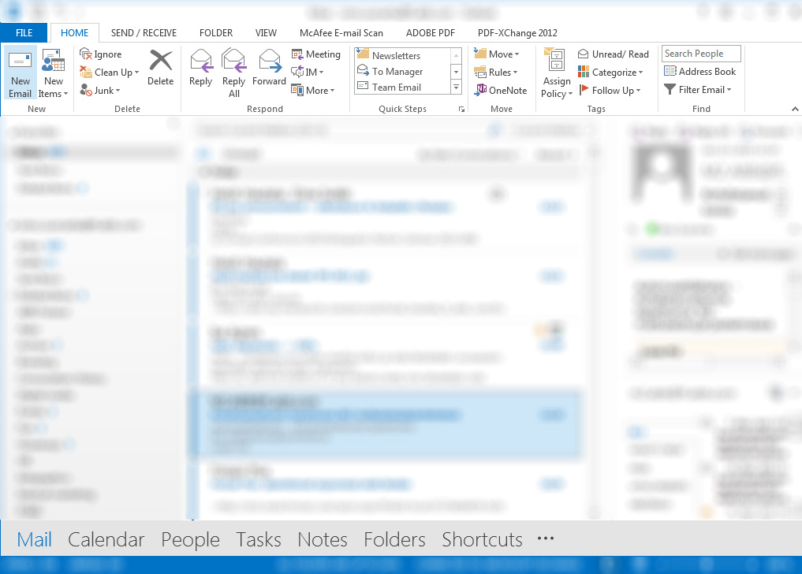

3
Click on “Signature” and
continue to “Signatures…”

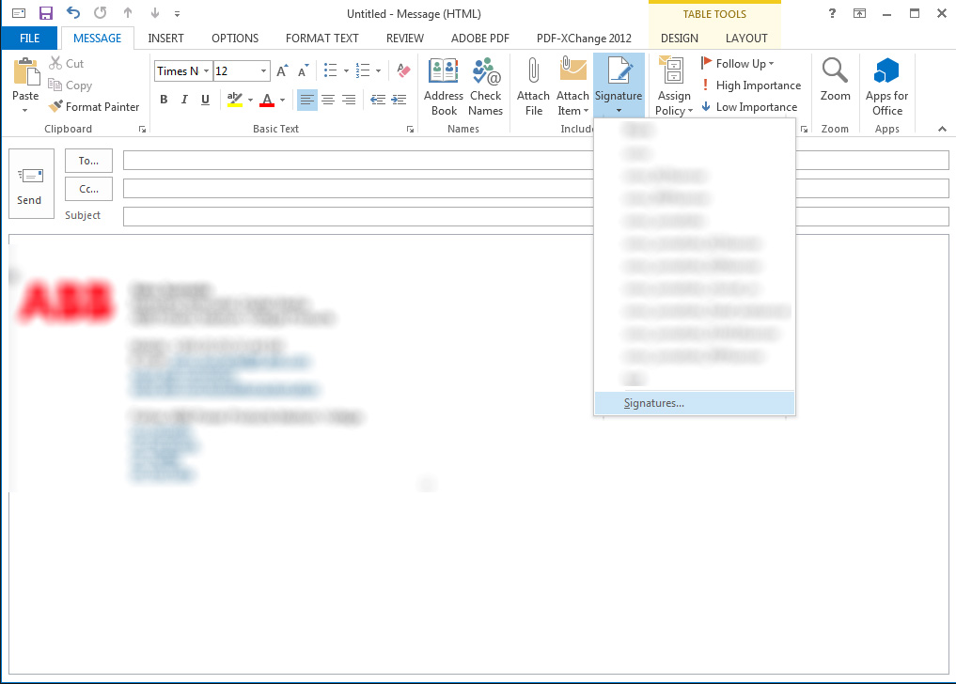

4
Select signature to add the banner to,
scroll down to the bottom and place the cursor to an empty row after your signature

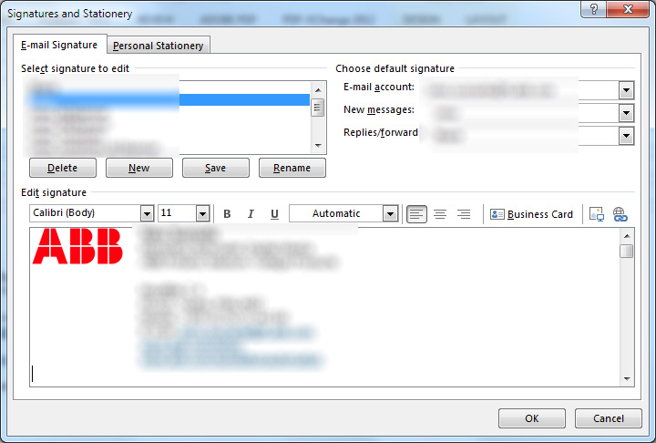

4
Paste (ctrl+v) the banner to
your signature and click “OK”

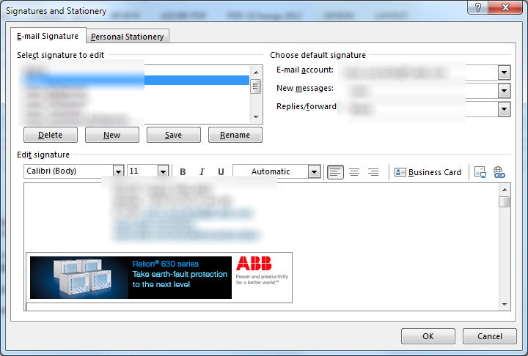

5
Congratulations! You are now ready to
promote our products and services using
email banners!

Your email banner also includes a link to a relevant web page.

Additionally, you can create multiple signatures with different banners to choose from. Additional signatures will appear in the same menu as seen in step 3.

