LCA

Communication to the agents
  - Zen-IT 1.1 Double-pole switch 2CLA210129N1101

Contents
1. Introduction 2
1.1. Quality and environmental management 2
1.2. Purpose of the study 2
1.3. Eco-designed product 3
1.4. Raw materials used 4
2. Considerations of the eco designed products 5
2.1. Usage considerations 5
2.2. Recyclability considerations 5
2.3. Environmental improvements 5
3. Impacts 6
3.1. Methodology and data 6
3.2. Environmental impacts 6
3.3. Comparative 7
4. Conclusions 8

Introduction

Quality and environmental management
Our policy of continuous improvement also requires a demanding and responsible work, which has led to the implementation of the UNE-EN-ISO 14006: Environmental management systems Guidelines for incorporating eco-design in our Quality Management System and Environment.
Eco-design is understood as a process integrated within the design and development that aims to reduce environmental impacts and continually to improve the environmental performance of the products, throughout their life cycle from raw material extraction to end of life.
In order to be of benefit to our organization and to ensure that we achieve our environmental objectives, we carry out eco-design as an integral part of the business operations of our organization.
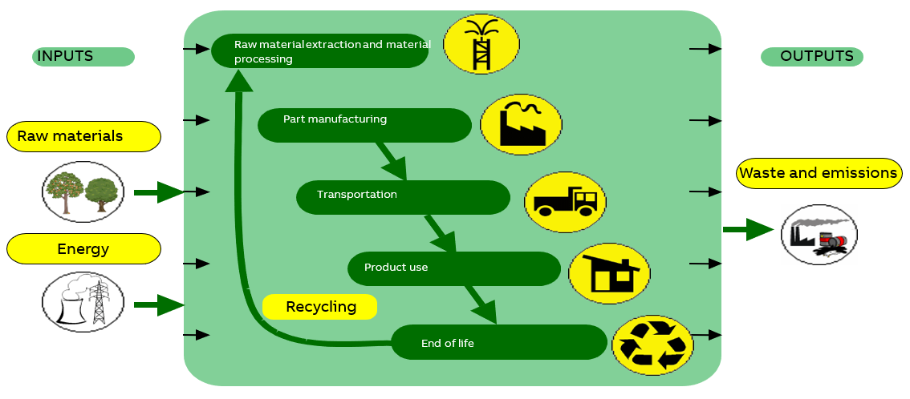
So, in 2007 Asea Brown Boveri, S.A. NIESSEN factory, certify the Environmental Management Design and Development process according to UNE 150301. To subsequently adapt the system to the international standard UNE EN ISO 14006.

ED-0008/2007

Purpose of the study
In this study, the double-pole switch has been environmentally analyzed to seek for an improvement. It has been compared to the Mylos the bolt-nut mechanism. The rest of the mechanisms of these projects can be obtained based on the double-pole, by adding phase contacts, screws and nuts. For that reason, the calculation for the whole family has been done adding the environmental impact of the extra parts needed to complete each product.

Eco-designed product
Representative products | Frames and mounting grids from the ZENIT and ZENIT ITALY range, in this case for a double-pole switch.
Description of the products | PC or PA based frames that provide protection to the switch and make possible to touch in order to turn on the swich. Moreover, there are metallic pieces which make up switch’s mechanism.
Functional unit | The system consisting of the frame, the mounting grid and mechanism, used to provide protection to the double-pole switch for 20 years.

Mylos (Before)

Zen-IT 1.1 (After)
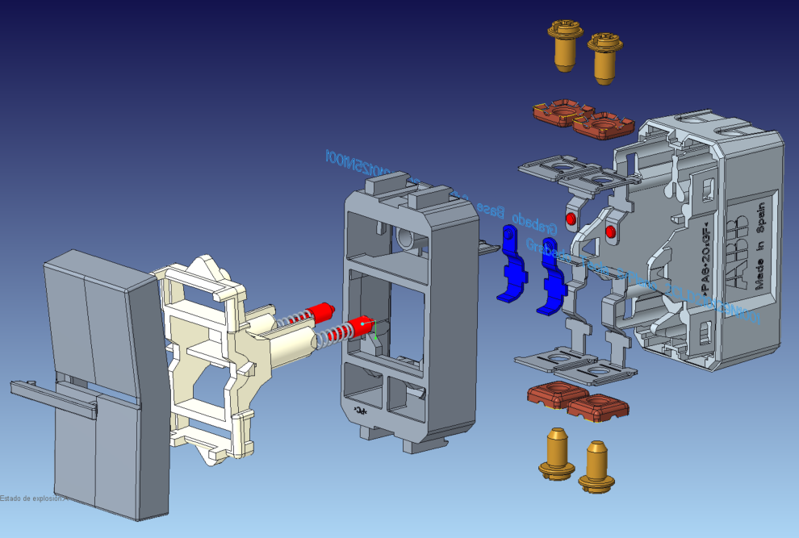
1
2
3
4
5
6
7
8
9
10
11
Part | Name | Material
1 | Visor/Trim | ABS
2 | Push-button | PC
3 | Inner rocker | PC
4 | Spring+Plunger | PA-Stainless Steel
5 | Intermediate Base | PC
6 | Moving contact | Brass and silver
7 | Contacto Interruptor | Brass and silver
8 | Contacto Fulcro | Brass
9 | Screw | Low-carbon steel with zinc coat
10 | Nut | Low-carbon steel with zinc coat
11 | Base | PA

Raw materials used
In this graph it is showed the allocation of the different material used to form the whole component.

What is named as “silver” in the new switch, it has a difference with the old one. Previously, the silver elements, which make the contact in the mechanism, were welded, now however, they are riveted which makes possible to use a different composition, using a mix of copper, a metal with less damaging impact than the silver.

Considerations of the eco designed products

Usage considerations
- Make strong electrical connections; this will prevent heat loss in connections, and unnecessary energy consumption.

Recyclability considerations
-The cardboard packaging is recycled.
-The plastics are recyclable, and they include a marking inside (indicating the material they are made of) so they can be disassembled.

Environmental improvements
- Minimum cardboard for recyclable packaging.
- Minimum number of components, thereby savings in energy and raw materials in manufacturing processes.
- The change of components in the electronic circuit achieves a reduction in energy consumption in the use stage.
- The change of components in the electronic circuit achieves a reduction in energy consumption in the standby stage.
- Use of a different composition for the silver.
- Optimization of the raw materials used, polymers especially.

Impacts

Methodology and data
For this analysis the software Simapro Flow has been used, with the database Ecoinvent 3.6 Cut-off.
The calculations have been made with the methodologies IPCC GWP 100a and CML-IA baseline. With this methodology is studied the abiotic depletion, the air pollution, the ozone layer depletion, the water pollution, the photochemical oxidation, eutrophication, global warming and the acidification.
It is taken into account the entire lifecycle, which include the manufacturing, transport, use and the end-of-life stages. As we are comparing a modification in an element, in many of the stages (transport, use and end of life) there is not any variation.
The data has been obtained from the company’s data base SAP and different technical datasheet.

Environmental impacts
Using the “CML-IA baseline” method, these compulsory indicators are calculated, which explanations are in the Appendix.
Double-pole switch Mylos
Impact indicators | Unit | Total | Manufacturing | Transport | Use | End of Life
Ozone depletion (OD) | kg CFC-11 eq. | 1,037E-08 | 9,20E-09 | 1,42E-09 | 0,00E+0 | -2,51E-10
Photochemical ozone creation (POCP) | kg C₂H₄ eq. | 1,316E-04 | 1,13E-04 | 9,97E-07 | 0,00E+0 | 1,79E-05
Eutrophication (E) | kg (PO₄)³ eq. | 1,758E-03 | 1,62E-03 | 5,43E-06 | 0,00E+0 | 1,35E-04
Global warming (GW) | kg CO₂ eq. | 3,237E-01 | 2,34E-01 | 7,65E-03 | 0,00E+0 | 8,24E-02
Depletion of abiotic resources – elements (ADPe) | kg Sb eq. | 3,154E-04 | 3,15E-04 | 2,69E-08 | 0,00E+0 | -2,36E-08
Acidification of soil and water (A) | kg SO₂ eq. | 2,891E-03 | 2,88E-03 | 2,44E-05 | 0,00E+0 | -1,54E-05
Depletion of abiotic  resources – fossil fuels (ADPff) | MJ | 2,812E+00 | 2,74E+00 | 1,144E-01 | 0,00E+00 | -4,267E-02
Water pollution (WP) | m³ | 1,279E+01 | 1,27E+01 | 4,599E-03 | 0,00E+00 | 8,204E-02
Air pollution (AP) | m³ | 2,733E+01 | 2,72E+01 | 1,391E-01 | 0,00E+00 | -1,360E-03

Double-pole switch Zen-IT 1.1
Impact indicators | Unit | Total | Manufacturing | Transport | Use | End of Life
Ozone depletion (OD) | kg CFC-11 eq. | 8,567E-09 | 7,401E-09 | 1,42E-09 | 0,00E+0 | -2,51E-10
Photochemical ozone creation (POCP) | kg C₂H₄ eq. | 1,009E-04 | 8,203E-05 | 9,97E-07 | 0,00E+0 | 1,79E-05
Eutrophication (E) | kg (PO₄)³ eq. | 1,171E-03 | 1,031E-03 | 5,43E-06 | 0,00E+0 | 1,35E-04
Global warming (GW) | kg CO₂ eq. | 2,924E-01 | 2,023E-01 | 7,65E-03 | 0,00E+0 | 8,24E-02
Depletion of abiotic resources – elements (ADPe) | kg Sb eq. | 3,201E-04 | 3,201E-04 | 2,69E-08 | 0,00E+0 | -2,36E-08
Acidification of soil and water (A) | kg SO₂ eq. | 1,975E-03 | 1,966E-03 | 2,44E-05 | 0,00E+0 | -1,54E-05
Depletion of abiotic  resources – fossil fuels (ADPff) | MJ | 2,491E+00 | 2,419E+00 | 1,144E-01 | 0,00E+00 | -4,267E-02
Water pollution (WP) | m³ | 7,719E+00 | 7,632E+00 | 4,599E-03 | 0,00E+00 | 8,204E-02
Air pollution (AP) | m³ | 1,727E+01 | 1,714E+01 | 1,391E-01 | 0,00E+00 | -1,360E-03

Comparative

The graphic shows the changes made and the differences in the global warming impact. As mentioned before, all the impact differences are made in the manufacturing stage. However, it could see that the ways to reduce the environmental impacts have not been effective as the GWP has grown slightly.

Conclusions

With this graphic can conclude as it is shown the impact associated to each raw material. In this way, it is possible to identify the variation in the impact that each part of the single-pole switch produce:
- Channging the unions between the different parts of the comonent cause the change of the material and the element employed. Although the amount of material has been increased, as the copper is less harmful for the enviromnt than than the silver, the use of this material decreases the GWP.
- Changing the method of unions for the parts that make the contact in the mechanism makes posible to change the composition of material used. However, this can cause an increase in the mass of silver sed for the different contacts of the mechanism.
- The parts that protect the mechanism, which are made of PA and PC, as they have been developed with a lighter mass, they contaminate less.
- The main parts that form the mechanism, in the case of Mylos’ switch, are made of copper ans ESNIES’ of brass. This difference make posible to use less material although the material is a bit more harmful than the copper.

Overall, it has seen that the eco-design has been developed successfully as the new pieces that are going to use they have a lower GWP than they have been sold so far.

Note: The presentation of these texts’ wrath according to the medium used (web, catalogs, instructions) so it does not always have this format.

Cecilia de Acha
Development Responsible

03/03/2020
Appendix
Impact indicators | Description | Unit
Global warming (GW) | Indicator of potential global warming caused by emissions to air contributing to the greenhouse effect. Includes fossil and biogenic | kg CO₂ eq.
Ozone depletion (OD) | Indicator of emissions to air that contribute to the destruction of the ozone layer | kg CFC-11 eq.
Acidification of soil and water (A) | Indicator of the potential acidification of soils and water caused by the release of certain gases to the atmosphere | kg SO₂ eq.
Eutrophication (E) | Indicator of the contribution to eutrophication of water by the enrichment of the aquatic ecosystem with nutritional elements, e.g. industrial or domestic effluents, agriculture, etc. | kg (PO₄)³ eq.
Photochemical ozone creation (POCP) | Indicator of emissions of gases that affect the creation of photochemical ozone in the lower atmosphere (smog) because of the rays of the sun. | kg C₂H₄ eq.
Depletion of abiotic resources – elements (ADPe) | Indicator of the depletion of natural non-fossil resources | kg Sb eq.
Depletion of abiotic resources – fossil fuels (ADPf) | Indicator of the depletion of natural fossil resources | MJ (lower heating Value)
Water pollution (WP) | Indicator of the quantity of water necessary to dilute the toxic elements poured into water in all the stages of the product life cycle. | m³
Air pollution (AP) | Indicator of the quantity of air necessary to dilute the toxic elements emitted into the air in all the stages of the product life cycle. | m³

