- _{TECHNICAL CATALOG}
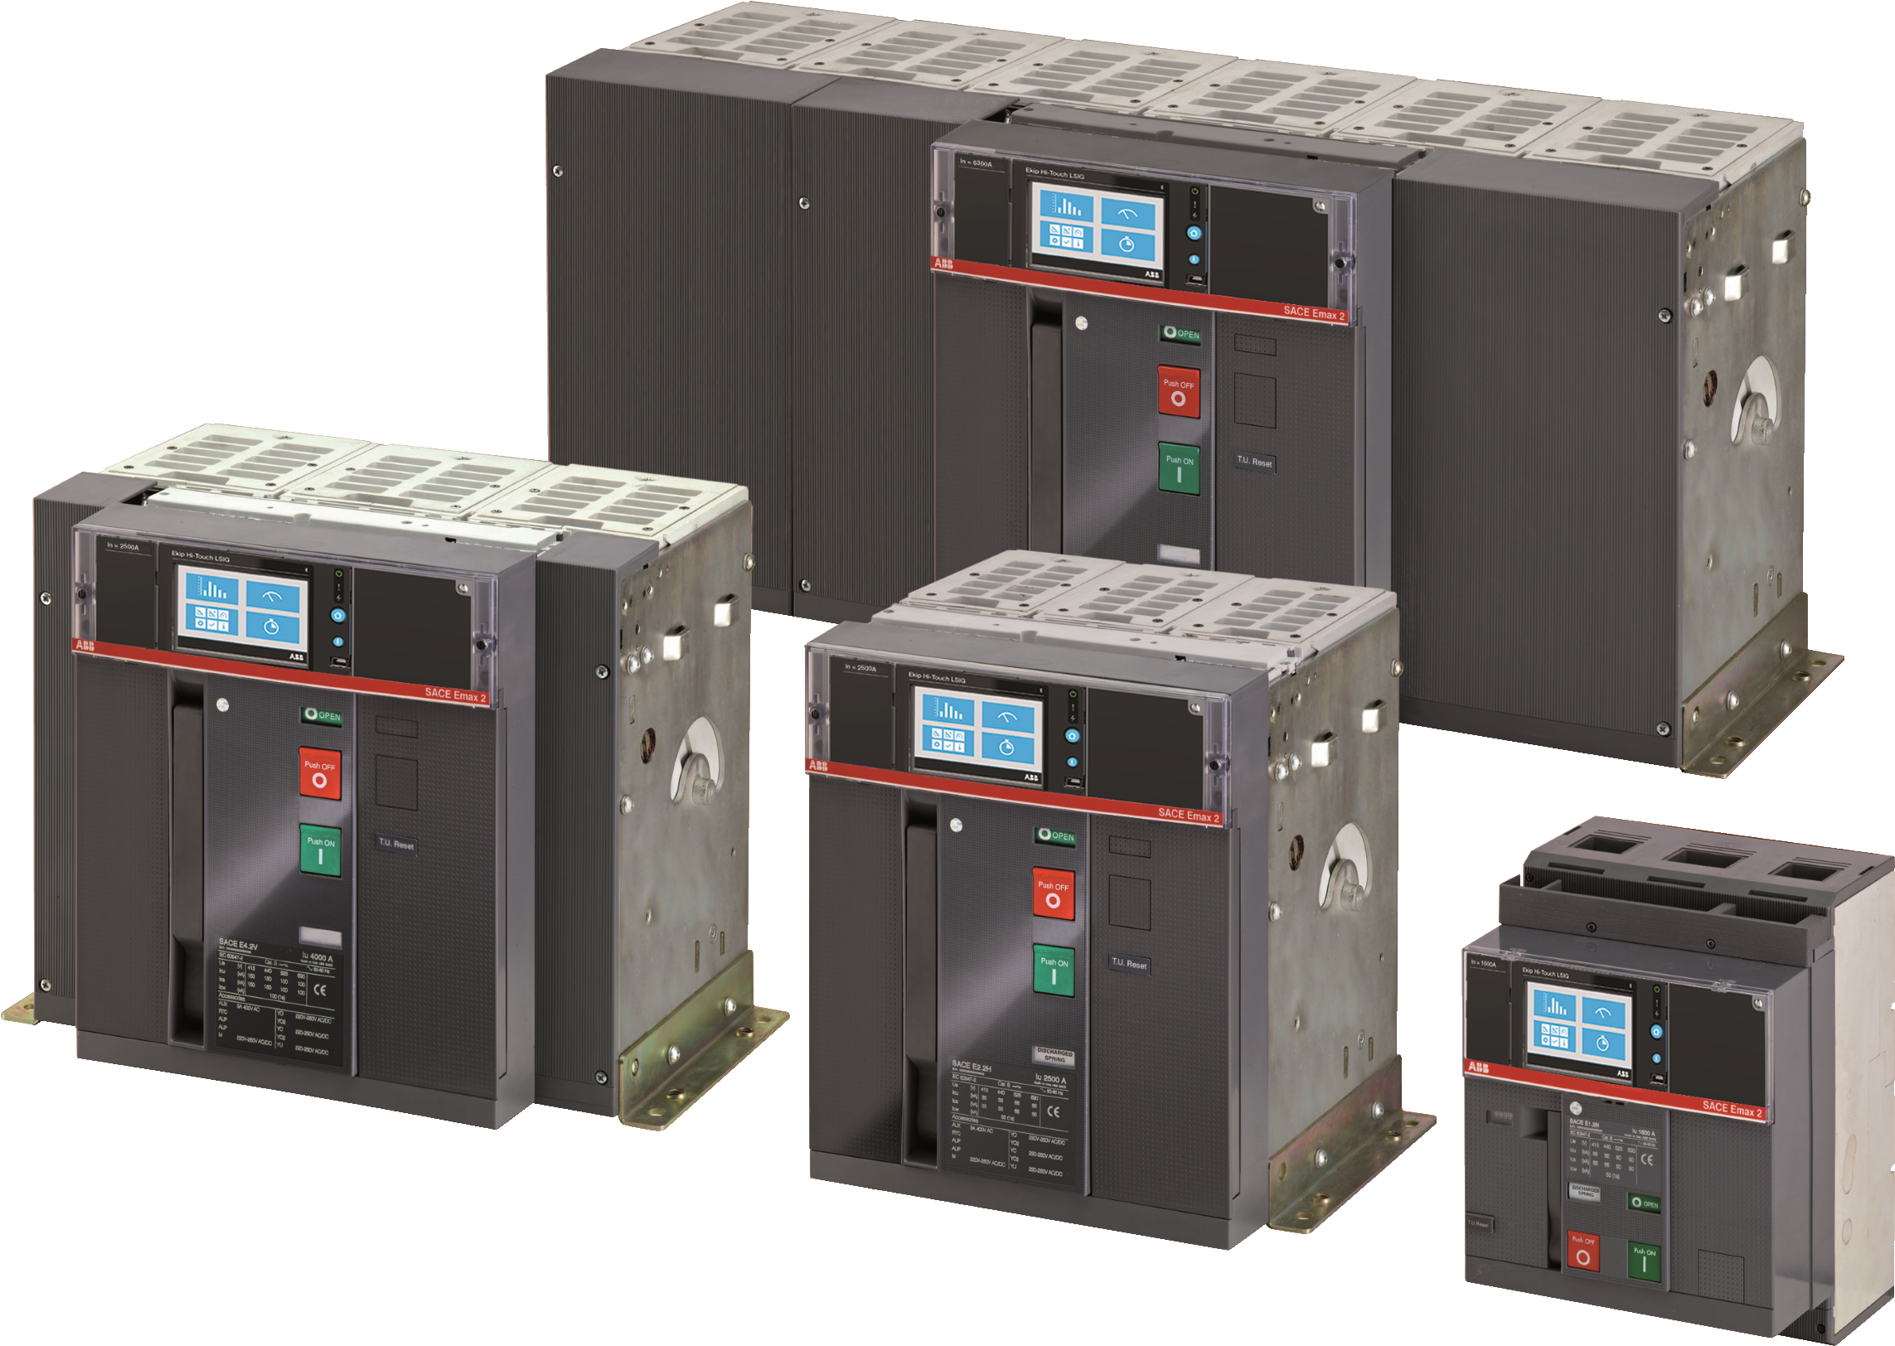
SACE Emax 2
Specification guide
2
—
Specification number: 26 01 20.17
Product name: Low voltage power circuit breakers

—

Part 1 — General
NOTE: ( ) Indicates option or a selection is to be made for quantity or applicability.

1.1 Summary
Circuit breakers shall be fixed or draw out type Emax 2 with Ekip electronic trip units in 3 pole or 4 pole versions. Circuit breakers shall have interrupting, and 30-cycle withstand ratings that meet the application requirements. Interrupting rating shall be available up to 100 kAIR RMS amperes without fuses. Thirty-cycle withstand rating available up to 100 kA to provide maximum coordination with downstream circuit breakers. Emax 2 circuit breakers shall be available in [250], [400], [800], [1000], [1200], [1600], [2000], [3200], [3600A], [4000], [5000] and [6000] A frame sizes.
The rated mechanical life of the circuit breaker shall be no less than 20,000 operations for E1.2 frame sizes of 1200 amperes and below.
The rated mechanical life of the circuit breaker shall be no less than 25,000 operations for E2.2 frame sizes of 2000 amperes and below.
The rated mechanical life of the circuit breaker shall be no less than 20,000 operations for E4.2 frame sizes of 3200 amperes and below.
The rated mechanical life of the circuit breakers shall be no less than 12,000 operations for E6.2 frame sizes up to 6000 amperes.
An adjustable rating plug (range of 0.4-1 times the sensor plug value) and a field-replaceable sensor plug (available in standard amperage steps from 50% to 100% of the frame size) shall determine the ampere rating of the circuit breaker. Circuit breakers shall be constructed in accordance with the following:
1.2 References Standards:
- IEEE C37.13-Low-Voltage AC Power Circuit Breakers Used in Enclosures
- ANSI C37.50-Test Procedures for Low-Voltage AC Power Circuit Breakers
- NEMA® SG-3-Low-Voltage Power Circuit Breakers
- UL® 1066-Low-Voltage AC and DC Power Circuit Breakers Used in Enclosures
- CSA 22.2 no. 31 switchgear assemblies

1.3 Quality assurance
Circuit breakers shall be UL Listed as Low-Voltage Power Circuit Breakers.

—

Part 2 — Products
2.1 Equipment, components and accessories

A. Circuit Breaker
- Circuit breaker shall be draw out or [fixed mount] type Emax 2 [manually] [electrically] operated.
- All circuit breaker operating mechanisms are to be stored energy devices with a maximum of 50ms closing time. With the breaker closed and the spring charged, breaker should be able to complete an Open-closeopen (O-C-O) cycle without recharging.
- Current-carrying components shall be completely isolated from the accessory mounting area and double insulated from the operator with accessory cover in place.
- Each phase inside the circuit breaker shall be completely isolated from other phases and grounded by polyester thermoset material.
- Circuit breaker must be equipped with an interlock to discharge the stored energy spring before the circuit breaker can be withdrawn from its cell. Circuit breaker must provide a positive ground.
- Primary connectors that can be rotated to provide flexible vertical or horizontal connections shall be available as an option. Front connections (only applicable for E1.2) shall also be available for shallow depth equipment designs. Connectors can be installed at the factory, time of commissioning or later by the user.
- Ready-to-close contact must be available to indicate remotely that the circuit breaker is “ready-to-close.” The circuit breaker is ready to close when it is open, spring mechanism is charged, a maintained closing order is not present, a maintained opening order is not present, and the circuit breaker is in an operational position.
- Secondary wiring shall be front accessible and available in spring terminal connections. Secondary wiring must not be accessible when switchgear door is closed.
- Circuit breaker shall be equipped with a visual contact wear indicator, visible from the display or from a PC using a communication unit.

B. Trip Unit
- Trip unit shall have the ability to be upgraded via downloadable software packages
- Circuit breaker trip system shall be an EKIP electronic trip unit.
- All trip units shall be removable to allow for field upgrades.
- Trip units shall incorporate “True RMS Sensing” and have LED long-time pickup indications.
- Trip unit shall provide local trip indication; information about which protection function tripped shall be readable at any time after the trip.
- Standard trip unit protection against short circuit delay shall allow fifteen settings from 0.6 to 10 times. Delays shall be in four options from 0.1 to 0.4 seconds.
- Standard trip unit protection against ground-fault shall allow for seven settings from 0.1 to 1 times ln. UL Breakers are limited to 1200A max setting. Delays shall be in three options from 0.1 to 0.8 seconds.
- (Advanced) trip system shall be programmable through a color touch-screen HMI.
- (Advanced) trip unit protection against overload shall allow fine settings of long-time pickup values (l1) from 0.4 to 1 times the rated current (ln), with a resolution of 0.001 ln. Protection against the overload delay settings shall be available to be chosen from 3 to 144 seconds with a resolution of 1s.
- (Advanced) trip unit protection against short circuit delay shall allow settings from 0.6 to 10 times ln with a resolution of 0.1 ln. Delays shall be available from 0.05 to 0.4 seconds with a resolution of 0.01s.
- (Advanced) trip unit protection against short circuit, instantaneous shall be available from 1.5 to 15 times ln with a resolution of 0.1 ln.
- (Advanced) trip unit protection against ground-fault shall allow settings from 0.1 to 1 times ln, with a
resolution of 0.1 ln. Delays shall be available from 0.1 to 1 seconds with a resolution of 0.05s. UL Breakers are limited to 1200A max setting for ground fault.
- (Advanced) trip units shall have communications capabilities by means of an optional add on module. Communication module may be installed at the factory, time of commissioning or later by the user. IEC 61850 [Modbus RTU, Profibus, Devicenet, Modbus TCP, EtherNet IP or Profinet are additional protocols that can be provided.
- (Advanced) a generator protection trip unit version should be available as an option.
- A power measurement module will let advanced units provide under voltage, under frequency, over frequency, phase sequence and reverse power protection functions. Additionally, this module shall supply power quality metrics including but not limited to THD (e.g., voltage sages, voltage swells). External voltage transformers shall not be required. Accuracy shall not be inferior to:
Measurements | Accuracy | Measurements | Accuracy
Current | 0.50% | Total Apparent Power | 1%
Voltage | 0.50% | Total Active Energy | 1%
Frequency | 0.10% | Total Reactive Energy | 2%
Total Active Power | 1% | Total Apparent Energy | 1%
Total Reactive Power | 2%

C. Accessories (Optional)
Circuit breakers shall be equipped with the below listed accessories. All accessories shall be UL Listed as field installable and be interchangeable between frame sizes. Circuit breakers shall provide isolation from primary power when accessory cover is removed.
3
Secondary wiring shall be front accessible and available in spring terminal connections. Secondary wiring should not be accessible when switchgear door is closed.
1. Standard Accessories:
- IP 30 Protection for switchgear door.
- Locking lifting plates for E2.2..E6.2
- Front terminals for E1.2
- Adjustable rear terminals for E2.2..E6.2 circuit
breaker mounted in HR – HR Configuration
(exception of 3200, 3600a, and 6000A)
The following accessories shall be available for the whole range:

1. Electrical Accessories
- Open/closed auxiliary contacts
- Auxiliary position contacts
- Ready to close contacts
- Shunt opening/closing release
- Second shunt opening and second shunt closing
release, for redundancy
- Undervoltage release
- Time-delay device for undervoltage release
- Geared motor for the automatic charging of the
closing springs, with limited inrush power (no more than 300 VA / 500 W)
- Mechanical and electrical signaling of overcurrent release trip
- Trip reset release; remote resetting of the circuit
breaker after a release has tripped due to overcurrent condition
- Auxiliary contacts (status, connected/test/disconnected position, ready to close, spring charged) that identifies the different circuit breaker conditions
- Current transformer for the neutral conductor
outside the circuit-breaker
- Homopolar toroid for the main power supply earth conductor (star center of the transformer)
- Homopolar toroid for residual current protection
(3…30 A)

2. Mechanical Accessories
Interlocks between two circuit-breakers or among three circuit-breakers shall have the possibility to be used horizontally, vertically or in “L” position using different types of cables (All cables can be cut to fit – respecting the minimum and maximum distances) that shall have these features:
- Standard version (with maximum distance between two circuit breakers: up to 1200 mm if horizontally interlocked while up to 750 mm if vertically interlocked)
- Extended version (with distance between two
circuit breakers: from 1200 mm up to 1600 mm if horizontally interlocked while from 750 up to 1000 if vertically interlocked)
- Extra-extended version (up to 2750 mm for
horizontal version, between 2 circuit breakers only)
- IP54 transparent front protection with double key locks. Sealable trip unit cover to prevent unauthorized access.

4

Electronic trip unit Ekip Dip Ekip Touch Ekip G Touch Ekip Hi Touch
 |  |  | Ekip Hi-G Touch
Solution | Ekip trip units + Ekip Multimeter
Type of trip units connectable to Ekip Multimeter | Ekip trip units
Number of trip units connectable to Ekip Multimeter | 1
Measurement functions
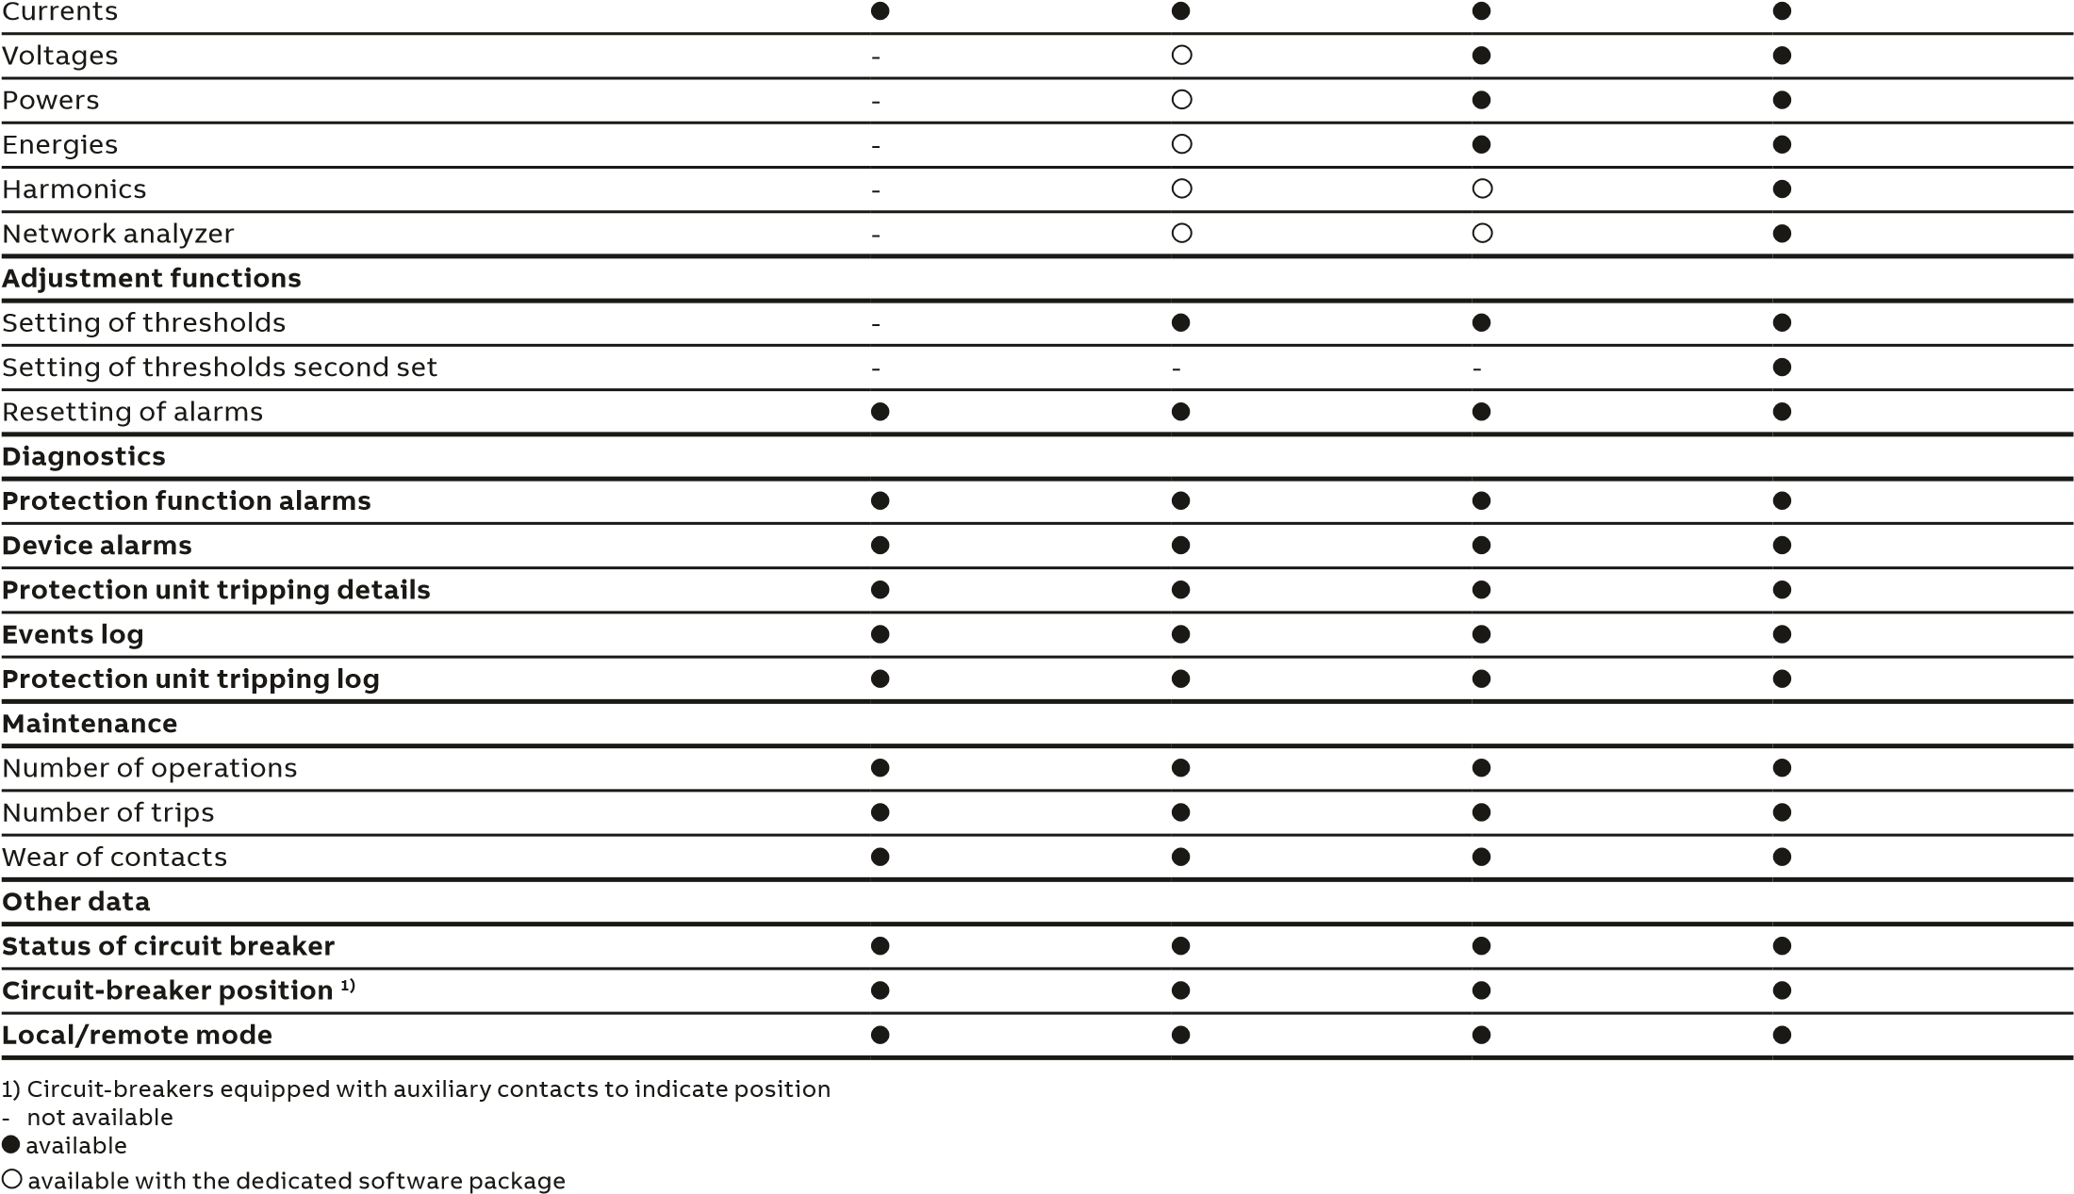
5

Electronic trip unit Ekip Dip Ekip Touch Ekip G Touch Ekip Hi Touch
 |  | Ekip Hi-G Touch
Solution | Ekip protection trip units equipped with Ekip link module  + Ekip Control Panel operator panel + standard EtherNet™ compone | nts
Type of trip units connectable | Ekip protection trip units
Number of trip units connectable to the Ekip link system | up to 30 ¹⁾
Data exchange rate of Ekip link system | 100 Mbit/sec
Supervision and control functions
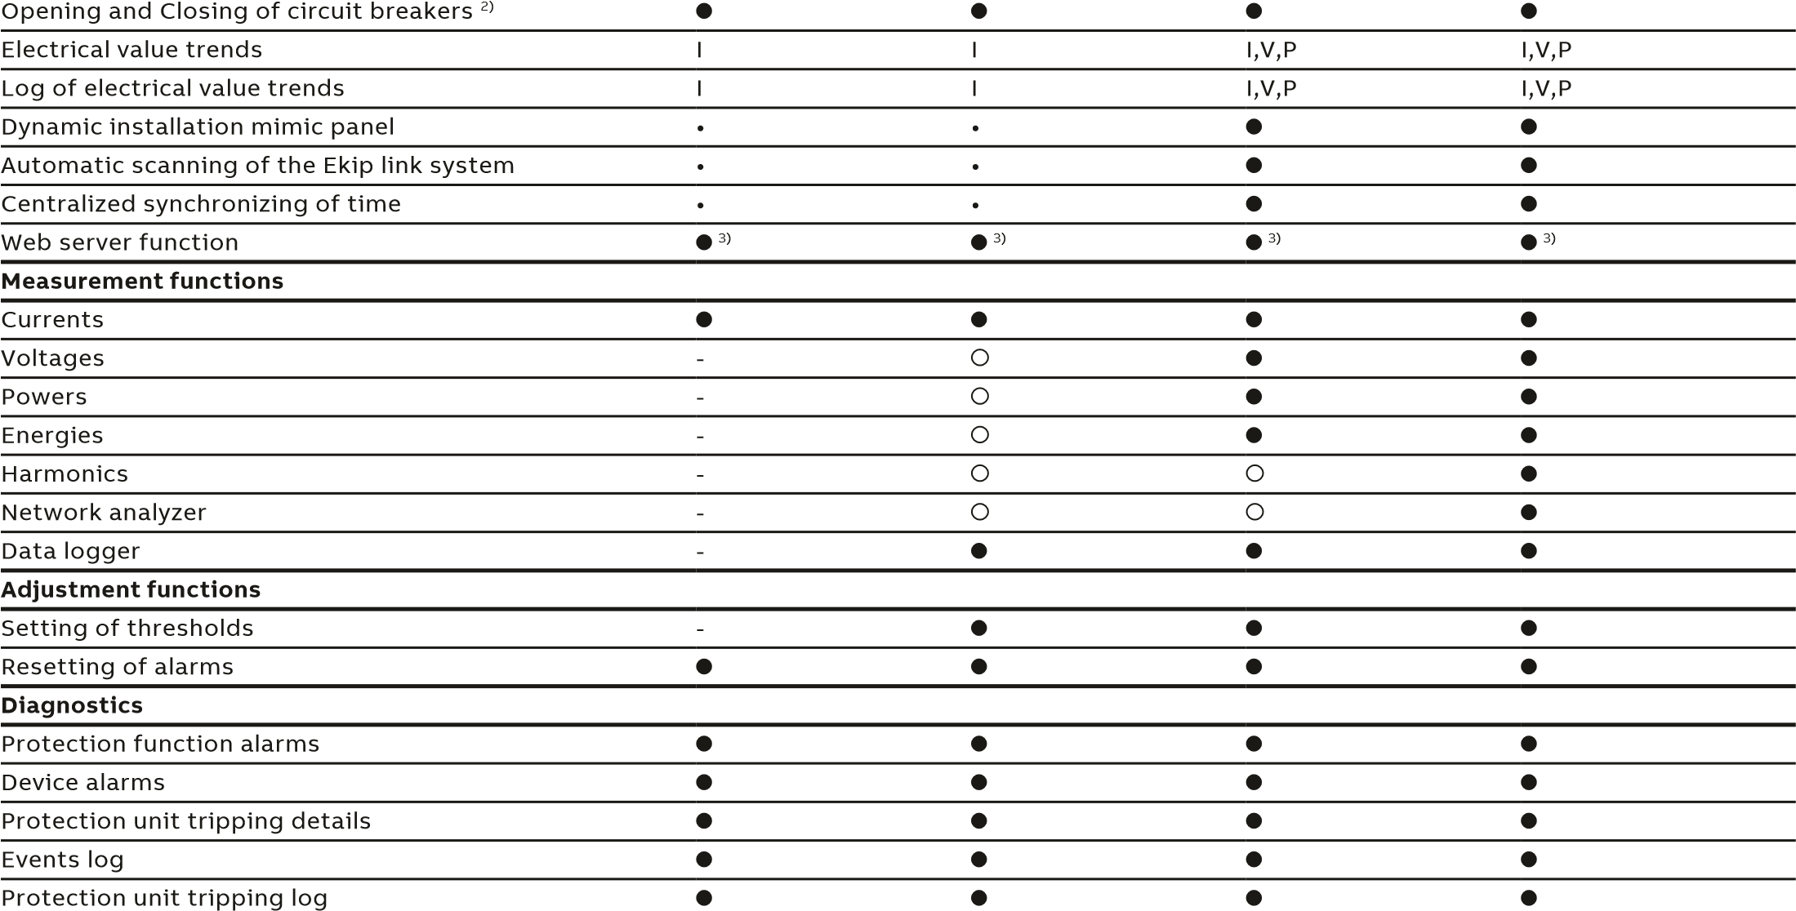
Transmission of alarms via text message | optional | optional | optional | optional
Transmission of alarms via e-mail | optional | optional | optional | optional
Maintenance
Number of operations
Number of trips
Wear of contacts
Other data
Status of circuit breaker
Circuit-breaker position
4)
Local/remote mode
- Ekip Control Panel is available in two versions that can manage a maximum of 10 or 30 circuit breakers. The number of circuit breakers may vary depending on their type.
For details, ask ABB SACE
- Circuit-breakers equipped with actuation module, electric accessories, opening and closing releases and spring charging motor3) Two client web accesses included in the licence
4) Circuit-breakers equipped with auxiliary contacts to indicate position
- not available available available with the dedicated software package

—
www.abb.us/lowvoltage

ABB Electrification Products
8155 T&B Boulevard
Memphis, TN 38125
USA Technical Support: 888-385-1221
Customer Service: 888-862-3290 7:00 a.m. – 5:00 p.m., CST, Monday – Friday lvps.support@us.abb.com
1
SXU210225L0201US
© Copyright 2020 ABB. All rights reserved. The data and illustrations are not binding. We reserve the right to modify the contents of this document on the basis of technical development of the products, without prior notice.

